BLUEPRINT BUSINESS PROCESS
01.01 General Parameters
Organization Structure & Valuation

Project Name | PT. Urecel Indonesia
Team Lead | Jennie Lou

Approved by | Name | Signature
Project Manager | Irwan Augusta
 | Iwan Budi Saputro
 | Petrus Eka Margo
Business Process Owner | Irwan Augusta
 | Iwan Budi Saputro
 | Bayu Pramono
 | Nor Hisyam
 | Herry Setyadi
 | Alifia Herlina Zulfiana
 | Novi Anggriani
 | Desi Intan Pratiwi
 | Ahmad Lala Saladin
 | Syarif Ahmad Nur

Table of Contents

1. General Parameter 4
1.1. Company Details 4
1.1.1. General 4
1.1.2. Accounting Data 5
1.1.3. Basic Initialization 6
1.2. General Settings 6
1.2.1. Business Partner 7
1.2.2. Budget 8
1.2.3. Services 8
1.2.4. Display 9
1.2.5. Path 10
1.2.6. Inventory 10
1.2.7. Resources 11
1.2.8. Cash Flow 11
1.2.9. Cost Accounting 12
1.2.10. Pricing 12
1.2.11. Hide Functions 13
1.3. Posting Period 14
1.4. Profit Center/Cost Center 14
1.5. Payment Terms 16
1.6. Currencies 17
1.7. Tax Group & Withholding Tax 17
1.8. House Bank 19
1.9. Banks 19
1.10. Document Setting (General) 22
1.11. Document Numbering 23
1.12. Units of Measure 28
1.13. Unit of Measure Groups 29
1.14. Sales Employee/Buyer 29
1.15. Freight 29
1.16. Landed Cost 31
1.17. Shipping Type 32
1.18. Payment Methods 32
1.19. License, Users, & Authorizations 33
1.20. Remarks 39
2. Organization Structure 40
3. Functional Gap 41
3.1. Validation 41
3.1.1. SP Transaction Notification 41
3.1.2. Addon 41
3.1.3. Formatted Search 58
3.2. User-Defined Field (UDF) 58
3.3. User Defined Object (UDO) 60
3.4. User Defined Table (UDT) 63
3.5. Other 66
3.6. Report 68
4. Integration 68
5. Comments 68
6. Version Control 69

General Parameter

Company Details

General
Local Language:
- Company Name : PT. URECEL INDONESIA
- Address (Tangerang)
- Street : Jl. Raya Serang KM 21 KP Cibadak RT 17 RW 07, Bojong Cikupa
- City : Kab. Tangerang
- State : Banten
- Zip Code : 15710
- Country : Indonesia
- Contact (Tangerang)
  - Internet Address : https://urecel.com/
  - Tel 1 : +6221 596 0557
  - Tel 2 :
  - Fax :
  - Email : admin@urecel.co.id
- Address (Jepara)
- Street : Dusun Suwawal, Kec. Mlonggo
- City : Kab. Jepara
- State : Jawa Tengah
- Zip Code : 59452
- Country : Indonesia
- Contact (Jepara)
  - Internet Address : https://urecel.com/
  - Tel 1 : +62291 5900 777
  - Tel 2 :
  - Fax :
  - Email : admin@urecel.co.id

Foreign Language:
- Company Name : PT. URECEL INDONESIA
- Address (Tangerang)
- Street : Jl. Raya Serang KM 21 KP Cibadak RT 17 RW 07, Bojong Cikupa
- City : Kab. Tangerang
- State : Banten
- Zip Code : 15710
- Country : Indonesia
- Contact (Tangerang)
  - Internet Address : https://urecel.com/
  - Tel 1 : +6221 596 0557
  - Tel 2 :
  - Fax :
  - Email : admin@urecel.co.id
- Address (Jepara)
- Street : Dusun Suwawal, Kec. Mlonggo
- City : Kab. Jepara
- State : Jawa Tengah
- Zip Code : 59452
- Country : Indonesia
- Contact (Jepara)
  - Internet Address : https://urecel.com/
  - Tel 1 : +62291 5900 777
  - Tel 2 :
  - Fax :
  - Email : admin@urecel.co.id

Accounting Data
- ID TKU : 000000
- Tax Office : JL. RAYA SERANG KM. 21 KP CIBADAK RT.17 RW.07, BOJONG CIKUPA, KABUPATEN TANGERANG, BANTEN, 15710
- NPWP : 0020265609052000

Basic Initialization
No | Description | Value
 | Local Currency | IDR (Indonesian Rupiah)
 | System Currency | IDR (Indonesian Rupiah)
 | Display Credit Balance with Negative Sign | Y
 | Allow Negative Amounts for Reversal Transaction Posting | N
 | Permit More than One Document Type per Series | N
 | Use Perpetual Inventory | Y (Each Transaction of Inventory item is reflected in the inventory GL Account)
 | Item Groups Valuation Method | Moving Average  Standard  FIFO
 | Manage Item Cost Per Warehouse | Y (per Warehouse)  N (per Company)
 | Use Purchase Accounts Posting System | N
 | Allow Stock Release Without Item Cost | Y
 | Manage Serial and Batch Cost By | Item Group Valuation Method  Serial/Batch Valuation Method
 | Enable Separate Net and Gross Price Mode | N
 | Enable Fixed Assets | Y
 | Calculate Depreciation By | Month
 | Enable Multiple Branches | Y
 | Mask Credit Card Number | Y
 | Enable Advanced G/L Account Determination | Y
 | Allow Selection of Any Account Type for Revenue Accounts | Y
 | Enable Project Management | Y

General Settings

Business Partner
No | Description | Value
 | Customer Activity Restrictions
 | Credit Limit | Y
 | Commitment Limit | Y
 | Consider Deliveries Balance | N
 | Restriction On Document:
 | A/R Invoice | Y
 | Delivery | Y
 | Sales Order | Y
 | Pick List | N
 | Set Commission by
 | Sales Employee | N
 | Items | N
 | Customers | N
 | Approval Process
 | Enable Approval Process | Y
 | Enable Approval Process in DI | N
 | Enable Updating the Document Generated/Updated by Approval Process | Y
 | Enable Originator to Update the Document Draft in Pending/Approved Status | Y
 | Enable Authorizer to Update Document Draft in Pending Status | Y
 | Payment Terms Preferences
 | Default Payment Term for Customer | D 30 AFTER RECEIVED INVOICE
 | Default Payment Term for Vendor | D 30 AFTER RECEIVED INVOICE
 | Apply Changes in BP Fields to New Business Partners Only | N
 | Use Shipped Goods Account for Customer | Y
 | Display Inactive Business Partners in Reports | Y
 | Display Inactive Business Partners in Marketing Documents | N
 | Display Inactive Contact Persons in Business Partner Master Data | Y
 | Allow Updating Address ID | Y
 | Enable Filtering Mechanism by Branch | N
 | Set Default Price List in General Settings Instead of in Payment Terms | N
 | Auto. Assign New Branches to Existing Business Partner | Y

Budget
No | Description | Value
 | Enable Budget Initialization | Y
 | For a Document that Deviates from the Budget | Block Deviation from Budget  Warning  Without Warning
 | Deviates Period | For Annual Budget  For Monthly Budget
 | Document Deviates from Budget
 | Purchase Request | N
 | Purchase Order | Y
 | Goods Receipt POs | Y
 | Accounting | Y

Services
No | Description | Value
 | At the Beginning of Each Session
 | Perform Data Check | N
 | Open Exchange Rates Table | N
 | Display Recurring Postings on Execution | N
 | Display Recurring Transaction on Execution | N
 | Send Alert for Activities Scheduled for Today | N
 | Display Inbox When New Message Arrives | Y
 | Display Latest Message/Alerts | N
 | Display Worklist When New Task Arrives | Y
 | Enable Transaction Notification | Y
 | Enable Alert Service | Y
 | Update Messages (Min.) | 5
 | Screen Locking Time (Min.) | 30
 | Use Numeric Keypad ENTER Key as TAB Key | N

Display
No | Description | Value
 | Date & Time
 | Date Format | CCYY/MM/DD
 | Time Format | 24H
 | Date Separator | .
 | Decimal Places
 | Amounts | 2
 | Price | 2
 | Rates | 4
 | Quantities | 4
 | Percent | 4
 | Units | 4
 | Decimals in Query | 2
 | Decimal Separator | .
 | Thousands Separator | ,
 | Display Currency on the Right | Y
 | Exchange Rate Posting | Direct  Indirect

Path
- Picture : \\192.168.155.112\hanab1h\Picture\
- Attachment : \\192.168.155.112\hanab1h\Attachment\

Inventory
No | Description | Value
 | Management Method | On Every Transaction  On Release Only
 | Issue Primarily By | Serial and Batch Numbers  Bin Locations
 | Unique Serial Numbers by | None  Mfr Serial No.  Serial Number  Lot Number
 | Display Batch Quantities By | Document Row UoM  Inventory UoM
 | Basic Setting for Batch Status | Released  Not Accesible  Locked
 | Block Multiple Receipts for Same Batch with Serial/Batch Valuation Method | N
 | Display Inactive Items In
 | Reports | Y
 | Marketing Documents | N
 | Default Warehouse | TN-FG001 (TANGERANG – FINISH GOOD)
 | Set Inventory Method By | Item Group  Warehouse  Item Level
 | Auto. Add All Warehouses to New and Existing Items | Y
 | Withholding Tax | Y
 | Auto. Add All UoM Group Definitions to New and Existing Items | Y
 | Auto. Add All Package Definitions to New and Existing Items | N
 | Open Item Master Data Instead of Bill of Materials of a BOM Item When Selecting Link Arrow | Y
 | Duplicate Bar Codes While Duplicating Items | N
 | Duplicate Prices While Duplicating Items | Y

Resources
No | Description | Value
 | Default Warehouse | TN-FG001 (TANGERANG – FINISH GOOD)
 | Auto Add All Warehouses to New Resources | Y
 | Default Capacity Period
 | Start From Today Until | Today  Month Start  Month End
 | Start From Today Until | + 1 Months
 | Start From Today Until | + 0 Days

Cash Flow
No | Description | Value
 | Assignment of Cash Flow Line Item | Optional  Mandatory
 | Default Primary Form Cash Flow Line Item
 | Incoming Payment | Payments for Invoices from Customers
 | Outgoing Payment | Payments for Invoices to Suppliers
 | Assignment in Transaction with All Relevant Cash Flow | Ignore Without Warning  Warning Only

Cost Accounting
No | Description | Value
 | Use Multidimensions | Y
 | Display Distribution Rules | In a Unified Column  In Separate Columns
 | Specify how to post journal entry line without a distribution rule or project when G/L account is set up for cost accounting
 | Distribution Rule | Block Posting  Without Warning
 | Project Code | Without Warning  Block Posting
 | Apply to Period-End Closing | N
 | Apply to Automatically Created Transactions | Y
 | Cost Accounting Adjustment Setting
 | Default Series
 | Default G/L Account

Pricing
No | Description | Value
 | Display Zero Price in Documents if Price Source is Based on Inactive Price Lists
 | Period and Volume Discounts | N
 | Special Prices for Business Partners | N
 | Price Lists | N
 | Display Inactive Price List In
 | Reports | N
 | Sales, Purchasing and Inventory Documents | N
 | Settings | N
 | Remove Unpriced Items from Price List in Database | N
 | When UoM Conversion Rules Change | Update UoM Prices Accordingly  Remove UoM Prices  Keep Corresp. UoM Prices Unchanged  Keep All UoM Prices Unchanged
 | Remove or Update UoM Prices Based on Last Purchase or Evaluated Price Lists | N
 | Effective Price Considers All Price Sources | N

Hide Functions
No | Description | Show/Hide
 | Budget | Show
 | Payment Wizard | Show
 | Dunning Wizard | Show
 | Cost Accounting | Show
 | Serial Numbers and Batches | Show
 | Production | Show
 | MRP | Show
 | Units of Measure | Show

Posting Period
No | Description | Value
 | Posting Period | January – December
 | Sub-Periods | Year  Quarters  Months  Days
 | Create New Periods with ‘Due Date To’ in Next Financial Year | Y
 | Set to end of | December
 | Automatically Update Period Status to ‘Closing Period’ for Existing Periods | Y
 | Days After New Period Starts | 10

Profit Center/Cost Center
Dimension | Description
Dimension 1 | Branch
Dimension 2 | Department
Dimension 3 | Product Grouping
Dimension 4 | (Belum Digunakan)
Dimension 5 | (Belum Digunakan)

Effective from: 01 Jan 2025
Dimension | Dimension Name | Cost Center Code | Cost Center Name
1 | Branch | U1 | TANGERANG
1 | Branch | U2 | JEPARA NON KB
1 | Branch | U3 | JEPARA KB
2 | Department | B11000 | MD 1
2 | Department | B11010 | MD 2
2 | Department | B11020 | MD 3
2 | Department | B11030 | SALES MARKETING
2 | Department | B31000 | VEHICLE
2 | Department | B31100 | DELIVERY
2 | Department | B33100 | WAREHOUSE & INVENTORY
2 | Department | B35100 | PURCHASING
2 | Department | B36100 | QA
2 | Department | B41100 | LAB
2 | Department | B50000 | MANAGEMENT
2 | Department | B51000 | FINANCE, ACCOUNTING, & TAX
2 | Department | B52000 | GA
2 | Department | B53000 | HR
2 | Department | B54000 | COSTING
2 | Department | B55000 | DESIGN
2 | Department | B56000 | EXIM
2 | Department | B70000 | OPERATIONS
2 | Department | B71000 | PRODUCTION
2 | Department | B71110 | PPIC
2 | Department | B71120 | SAMPLE
2 | Department | B73100 | QUALITY CONTROL
2 | Department | B75100 | MAINTENANCE
2 | Department | B91000 | INFORMATION TECHNOLOGY
3 | Product Grouping | B71210 | FOAM UET
3 | Product Grouping | B71220 | FOAM UETR
3 | Product Grouping | B72110 | COMPRIBAND
3 | Product Grouping | B72120 | CARBON FILTER
3 | Product Grouping | B72130 | REBONDED
3 | Product Grouping | B72140 | BERIA
3 | Product Grouping | B72150 | BLOCK, SHEET, CTS
3 | Product Grouping | B72160 | CORE
3 | Product Grouping | B72170 | COVER
3 | Product Grouping | B72180 | CUSHION
3 | Product Grouping | B72190 | FIBER
3 | Product Grouping | B76000 | MERCHANDISE
3 | Product Grouping | B77000 | SERVICE

Payment Terms
Due date based on: Posting Date / Document Date / System Date
Payment Terms Code | Days
50% BEFORE PRODUCTION, 50% 30 DAYS AFTER DELIVERY | 30
50% BEFORE PRODUCTION, 50% BEFORE DELIVERY | 0
CASH ADVANCE | 0
CASH AFTER DELIVERY | 0
CASH BEFORE DELIVERY | 0
CASH ON DELIVERY | 0
D 120 AFTER DELIVERY DATE | 120
D 14 AFTER DELIVERY DATE | 14
D 14 AFTER RECEIVED INVOICE | 14
D 15 AFTER DELIVERY DATE | 15
D 2 AFTER DELIVERY DATE | 2
D 210 AFTER RECEIVED INVOICE | 210
D 30 AFTER DELIVERY DATE | 30
D 30 AFTER RECEIVED INVOICE | 30
D 40 AFTER DELIVERY DATE | 40
D 45 AFTER DELIVERY DATE | 45
D 45 AFTER RECEIVED INVOICE | 45
D 60 AFTER DELIVERY DATE | 60
D 60 AFTER RECEIVED INVOICE | 60
D 60 DAY AFTER B/L | 60
D 7 AFTER DELIVERY DATE | 7
D 7 AFTER RECEIVED INVOICE | 7
D 70 AFTER DELIVERY DATE | 70
D 70 AFTER RECEIVED INVOICE | 70
D 90 AFTER B/L DATE | 90
D 90 AFTER DELIVERY DATE | 90
D 90 AFTER RECEIVED INVOICE | 90
DOWN PAYMENT | 0

Currencies
Code | Currency | Amount / % |  | Rounding Method | Decimals
Code | Currency | Incoming | Outgoing | Rounding Method | Decimals
IDR | Indonesia Rupiah | 1000 | 1000 | No Rounding | Default
SGD | Singapore Dollar |  |  | No Rounding | 4 Digits
USD | US Dollar |  |  | No Rounding | 4 Digits
EUR | Euro |  |  | No Rounding | 4 Digits
AUD | Australian Dollar |  |  | No Rounding | 4 Digits
GBP | British Pound |  |  | No Rounding | 4 Digits

Tax Group & Withholding Tax
- TAX Group
- Category: Input Tax
Tax Code | Description | Rate | Effective From | GL Account
PPNI-NO | PPN Masukan 0% | 0 | 2025.01.01 | 111710100
PPNI-GN | PPN Masukan 11% General | 11 | 2025.01.01 | 111710100
PPNI-JT | PPN Masukan 1.1% Jasa Transportasi | 1.1 | 2025.01.01 | 111710100
PPNI-KB | PPN Masukan 11% Kawasan Berikat | 0 | 2025.01.01 | 111710100

- Category: Output Tax
Tax Code | Description | Rate | Effective From | GL Account
PPNO-NO | PPN Keluaran 0% | 0 | 2025.01.01 | 210550100
PPNO-GN | PPN Keluaran 11% General | 11 | 2025.01.01 | 210550100
PPNO-KB | PPN Keluaran 11% Kawasan Berikat | 0 | 2025.01.01 | 210550100

- WITHHOLDING TAX
WTax Code | WTax Name | Category | Effective From | Rate | G/L Account
21-1 | PPh 21 5% | Invoice | 2025.01.01 | 5 | 210510100
21-2 | PPh 21 2.5% | Invoice | 2025.01.01 | 2.5 | 210510100
21-3 | PPh 21 3% (Vendor Non NPWP) | Invoice | 2025.01.01 | 3 | 210510100
21-4 | PPh 21 Pesangon 5% | Invoice | 2025.01.01 | 5 | 210510100
21-5 | PPh 21 Pesangon 15% | Invoice | 2025.01.01 | 15 | 210510100
21-6 | PPh 21 Pesangon 25% | Invoice | 2025.01.01 | 25 | 210510100
22-1 | PPh 22 2.5% (Vendor) | Invoice | 2025.01.01 | 2.5 | 210510200
22-2 | PPh 22 0.3% (Vendor) | Invoice | 2025.01.01 | 0.3 | 210510200
22-3 | PPh 22 1.5% (Customer) | Invoice | 2025.01.01 | 1.5 | 111750200
23-1 | PPh 23 2% (Vendor) | Invoice | 2025.01.01 | 2 | 210510300
23-2 | PPh 23 2% (Customer) | Invoice | 2025.01.01 | 2 | 111750300
23-3 | PPh 23 4% (Customer) | Invoice | 2025.01.01 | 4 | 111750300
23-4 | PPh 23 15% (Customer) | Invoice | 2025.01.01 | 15 | 111750300
23-5 | PPh 23 4% (Vendor Non NPWP) | Invoice | 2025.01.01 | 4 | 210510300
26-1 | PPh 26 20% (Interest) | Invoice | 2025.01.01 | 20 | 210510500
42-1 | PPh Final 1.75% (Vendor Konstruksi) | Invoice | 2025.01.01 | 1.75 | 210510800
42-2 | PPh Final 4(2) 10% | Invoice | 2025.01.01 | 10 | 210510800
42-3 | PPh Final 4(2) 2% | Invoice | 2025.01.01 | 2 | 210510800
42-4 | PPh Final 4(2) 3% | Invoice | 2025.01.01 | 3 | 210510800
42-5 | PPh Final PP 23 0.5% | Invoice | 2025.01.01 | 0.5 | 210510800
43-1 | PPN KMS 2.4% | Invoice | 2025.01.01 | 2.4 | 210510910

House Bank
Bank Code | Branch | Account No. | Account Name | G/L Account
003 | KCU WISMA GKBI | H31-IBK:010000371812002 | PT. URECEL INDONESIA | 110133110
003 | Wisma GKBI - Jakarta | H31-IBK:010000371801001 | PT. URECEL INDONESIA | 110113111
003 | Wisma GKBI - Jakarta | H31-IBK:010000371801002 | PT. URECEL INDONESIA | 110133109
008 | KCP JEPARA | H32-MDR:1840017779008 | PT. URECEL INDONESIA | 110113203
008 | KCP JEPARA | H32-MDR:1840098889007 | PT URECEL INDONESIA | 110113204
013 | JAKARTA | H31-PMT:0902342966 | PT URECEL INDONESIA | 110133101
013 | PERMATA TOWER 1 | H31-PMT:0701377052 | PT URECEL INDONESIA | 110113101
014 | SUPERMALL KARAWACI | H31-BCA:7610471778 | PT URECEL INDONESIA | 110113102
014 | SUPERMALL KARAWACI | H31-BCA:7610549777 | PT URECEL INDONESIA | 110133102
014 | SUPERMALL KARAWACI | H31-BCA:7613097777 | PT. URECEL INDONESIA | 110113110
016 | SUPERMALL KARAWACI | H31-MAY:2290200020 | PT URECEL INDONESIA | 110113103
016 | SUPERMALL KARAWACI | H31-MAY:2290700020 | PT URECEL INDONESIA | 110133103
022 | MENARA ASIA | H31-CMB:704802240900 | PT. URECEL INDONESIA | 110113109
022 | PINANGSIA | H31-CMB:800108856600 | PT URECEL INDONESIA | 110113104
022 | PINANGSIA | H31-CMB:800109545140 | PT URECEL INDONESIA | 110133104
022 | PINANGSIA | H31-CMB:800156370850 | PT URECEL INDONESIA | 110133108
152 | INTERNATIONAL FINANCIAL CENTER 2 | H31-SHN:701000018331 | PT. URECEL INDONESIA | 110113108
152 | INTERNATIONAL FINANCIAL CENTER 2 | H31-SHN:701000018348 | PT. URECEL INDONESIA | 110133107
212 | JAKARTA | H31-BWS:150913911419 | PT URECEL INDONESIA | 110133106
212 | JAKARTA | H31-BWS:150913911567 | PT URECEL INDONESIA | 110113107

Banks
Bank Code | Bank Name | Country | BIC/SWIFT Code
002 | PT. BANK RAKYAT INDONESIA ( PERSERO ) TbK | Indonesia
003 | BANK IBK INDONESIA | Indonesia
008 | PT. BANK MANDIRI ( PERSERO ) Tbk | Indonesia
009 | PT. BANK NEGARA INDONESIA ( PERSERO ) Tbk | Indonesia
011 | PT. BANK DANAMON INDONESIA Tbk | Indonesia
013 | PT. BANK PERMATA Tbk | Indonesia
014 | PT. BANK CENTRAL ASIA Tbk | Indonesia
016 | PT. BANK MAYBANK INDONESIA TbK | Indonesia
022 | PT. BANK CIMB NIAGA Tbk | Indonesia
028 | PT. BANK OCBC NISP Tbk | Indonesia
031 | CITIBANK N.A, INDONESIAN BRANCH | Indonesia
041 | PT. BANK HSBC INDONESIA | Indonesia
042 | PT. BANK MITSUBISHI UFJ FINANCIAL GROUP | Indonesia
046 | PT. BANK DBS INDONESIA | Indonesia
050 | STANDARD CHARTERED BANK | Indonesia
076 | PT. BANK BUMI ARTA Tbk | Indonesia
113 | PT. BANK BPD JATENG | Indonesia
152 | BANK SHINHAN INDONESIA | Indonesia
212 | PT. BANK WOORI SAUDARA INDONESIA Tbk | Indonesia
451 | PT. BANK SYARIAH INDONESIA Tbk | Indonesia
484 | PT. BANK KEB HANA INDONESIA | Indonesia
535 | SEABANK INDONESIA | Indonesia
536 | PT. BANK BCA SYARIAH | Indonesia
ABOC | AGRICULTURAL BANK OF CHINA | China | ABOCCNBJXXX
BANCA | BANCA POPOLARE DELLEMILLIA ROMAGNA | Italy
BKHZCN | BANK OF HUZHOU CO., LTD | China | BKHZCNBHXXX
BNLI | BANCA NAZIONALE DEL LAVORO S.P.A | Italy | BNLIITRRXXX
BNP | BNP PARIBAS VIETNAM | Vietnam
BOA | BANK OF AMERICA N.A | USA
BOC | BANK OF CHINA | China | BKCHCNBJXXX
BOFA | BANK OF AMERICA, N.A | USA | BOFAUS3NXXX
BOH | BANK OF HANGZHOU CO. LTD | China
CITIC | CHINA CITIC BANK | China | CIBKCNBJ310
COBA | COMMERZBANK AG | Germany | COBADEFFXXX
CTBC | CTBC BANK CO LTD | Hong Kong
DGCCC | DONGGUAN RURAL COMMERSIAL BANK CO. LTD | China | DGCCCN22
DNBA | DNB NOR BANK ASA | Norway | DNBANOKKXXX
HASB | HONGKONG AND SHANGHAI BANKING CORPO | Hong Kong
HSBC | BANK HSBC HONGKONG | China | HSBCIDJAXXX
IBK | INDUSTRIAL BANK OF KOREA | South Korea | IBKOKRSEXXX
ICBC | INDUSTRIAL AND COMMERCIAL BANK OF CHINA | China | ICBKCNBJXXX
JPMORGAN | JPMORGAN CHASE BANK, N.A | USA | CHASUS33XXX
JTCB | JOINT STOCK COMMERCIAL BANK FOR FOREIGN TRADE OF VIETNAM | Vietnam
KEB KOREA | KEB HANA BANK | South Korea | KOEXKRSE
KOOKMIN | KOOKMIN BANK | China
MUFG | MUFG BANK Ltd | Japan | BOTKJPJTXXX
OCBC | PT. BANK OCBC NISP Tbk | Singapore
PBCC | CHINA CONSTRUCTION BANK CORPORATION | China | PCBCCNBJGDD
PBNK | DEUTSCHE POSTBANK AG | Germany | PBNKDEFFXXX
PNC PHILADELPHIA | PNC BANK N.A | USA | PNCCUS3CXXX
PNC USA | PNC BANK N.A | USA | PNCCUS33XXX
QILU | QILU BANK CO. LTD | China
QRCB | QINGDAO RURAL COMMERCIAL BANK COPORATION | China | QDRCCNBQXXX
RABO | RABOBANK PEELLAND ZUID | Netherlands
SHBK | SHINHAN BANK | Vietnam | SHBKVNVXXXX
SPAREKASSEN | SPAREKASSEN KRONJYLLAND | China
STDCB | STANDARD CHARTERED BANK | Singapore
TVBAT | TURKIYE VAKIFLAR BANKSI T.A.O | Turkey | TVBATR2AXXX
UNCR | UNICREDIT SPA | Italy | UNCRITM1M15
WBEH | WESTERWALD BANK EG HACHENBURG | Germany | GENODE51WW1

Document Setting (General)
No | Description | Value
 | Calculate Gross Profit | Y
 | Base Price Origin | Item Cost
 | Default Gross Profit % for Service Document | 0
 | Calculate % Gross Profit as: | Profit/Sales Price  Profit/Base Price
 | Document Remarks Include | Base Document Number  Manual Remarks Only  BP Reference Number
 | For a Sales BOM in Documents, Display: | Price and Total for Parent Item Only  Price for Component Items
 | Response to G/L Account Balance Outside Allowed Range: | No Warning  Warning Only  Block Posting
 | Response to Release / Receipt of Inventory Outside Defined Range | No Warning  Warning Only  Block Document Creation
 | Block Negative Inventory | Y
 | Block Negative Inventory By | Warehouse  Company  Item Setting
 | Rounding Method | By Currency  By Document
 | Exchange Rate Base Date (A/P Documents) | Posting Date  Document Date
 | Split Journal Entry Posting by Document Lines | No Split  Split in Journal Entry Preview Only  Split
 | Display Rounding Remark | Y
 | Use Warehouse Address | Y
 | Manage Freight in Documents | Y
 | Block Documents with earlier Posting Date | N
 | Allow Future Posting Date | Y
 | Use Document Exchange Rate When Copying to Target Document | Y
 | Copy Document References from Original Document to Duplicates | Y
 | Attachments
 | Copy Attachments from Base Document to Target Document | N
 | Copy Attachments from BOM to Production Order | N
 | Do Not Overwrite Attachments with the Same File Name | N
 | Copy Opening and Closing Remarks to Target Documents | Y
 | Manage Inventory by Warehouse | Y
 | Display Canceled and Cancelation Marketing Documents in Reports | Y
 | Max. No. of Days for Canceling Marketing Documents Before or After Posting | 360
 | Enable Advanced Available to Promise | N

Document Numbering
- Nomor dokumen akan direset per tahun, kecuali untuk dokumen Journal Entry tidak akan direset per tahun.
- Struktur penomoran dokumen dibuat dengan format 250100001, dengan detail:
  - 2 digit: tahun
  - 2 digit: Branch
    - 01: Tangerang
    - 02: Jepara (Kaber dan Non Kaber menggunakan kode yang sama)
  - 5 digit: running number
- Berikut contoh pembuatan Document Numbering untuk tahun 2026:
No | Document | Series Name | First Number | Last Number | Branch
 | A/P Credit Memos | 26APCM01 | 260100001 | 260199999 | TANGERANG
 |  | 26APCM02 | 260200001 | 260299999 | JEPARA
 | A/P Down Payment | 26APDP01 | 260100001 | 260199999 | TANGERANG
 |  | 26APDP02 | 260200001 | 260299999 | JEPARA
 | A/P Invoices | 26APIN01 | 260100001 | 260199999 | TANGERANG
 |  | 26APIN02 | 260200001 | 260299999 | JEPARA
 | A/R Credit Memos | 26ARCM01 | 260100001 | 260199999 | TANGERANG
 |  | 26ARCM02 | 260200001 | 260299999 | JEPARA
 | A/R Down Payment | 26ARDP01 | 260100001 | 260199999 | TANGERANG
 |  | 26ARDP02 | 260200001 | 260299999 | JEPARA
 | A/R Invoices | 26ARIN01 | 260100001 | 260199999 | TANGERANG
 |  | 26ARIN02 | 260200001 | 260299999 | JEPARA
 | BOM_Costing | 26PRBC01 | 260100001 | 260199999 | TANGERANG
 |  | 26PRBC02 | 260200001 | 260299999 | JEPARA
 | BOM_Mapping | 26PRBM01 | 260100001 | 260199999 | TANGERANG
 |  | 26PRBM02 | 260200001 | 260299999 | JEPARA
 | Deliveries | 26ARDO01 | 260100001 | 260199999 | TANGERANG
 |  | 26ARDO02 | 260200001 | 260299999 | JEPARA
 | Deposits | 26FIDP01 | 260100001 | 260199999 | TANGERANG
 |  | 26FIDP02 | 260200001 | 260299999 | JEPARA
 | Depreciation Run | 26FADR01 | 260100001 | 260199999 | TANGERANG
 |  | 26FADR02 | 260200001 | 260299999 | JEPARA
 | Fixed Asset Capitalization | 26FACP01 | 260100001 | 260199999 | TANGERANG
 |  | 26FACP02 | 260200001 | 260299999 | JEPARA
 | Fixed Asset Capitalization Credit Memo | 26FACM01 | 260100001 | 260199999 | TANGERANG
 |  | 26FACM02 | 260200001 | 260299999 | JEPARA
 | Fixed Asset Manual Depreciation | 26FAMD01 | 260100001 | 260199999 | TANGERANG
 |  | 26FAMD02 | 260200001 | 260299999 | JEPARA
 | Fixed Asset Retirement | 26FART01 | 260100001 | 260199999 | TANGERANG
 |  | 26FART02 | 260200001 | 260299999 | JEPARA
 | Fixed Asset Revaluation | 26FARV01 | 260100001 | 260199999 | TANGERANG
 |  | 26FARV02 | 260200001 | 260299999 | JEPARA
 | Fixed Asset Transfer | 26FATF01 | 260100001 | 260199999 | TANGERANG
 |  | 26FATF02 | 260200001 | 260299999 | JEPARA
 | Gen_ProdOrder_SMP | 26GNPS01 | 260100001 | 260199999 | TANGERANG
 |  | 26GNPS02 | 260200001 | 260299999 | JEPARA
 | GI_Generator | 26GIGN01 | 260100001 | 260199999 | TANGERANG
 |  | 26GIGN02 | 260200001 | 260299999 | JEPARA
 | Goods Issue | 26INGI01 | 260100001 | 260199999 | TANGERANG
 |  | 26INGI02 | 260200001 | 260299999 | JEPARA
 | Goods Receipt | 26INGR01 | 260100001 | 260199999 | TANGERANG
 |  | 26INGR02 | 260200001 | 260299999 | JEPARA
 | Goods Receipt PO | 26APGR01 | 260100001 | 260199999 | TANGERANG
 |  | 26APGR02 | 260200001 | 260299999 | JEPARA
 | Goods Return | 26APRT01 | 260100001 | 260199999 | TANGERANG
 |  | 26APRT02 | 260200001 | 260299999 | JEPARA
 | Goods Return Request | 26APRR01 | 260100001 | 260199999 | TANGERANG
 |  | 26APRR02 | 260200001 | 260299999 | JEPARA
 | Incoming Payment Order | 26IPPO01 | 260100001 | 260199999 | TANGERANG
 |  | 26IPPO02 | 260200001 | 260299999 | JEPARA
 | Incoming Payments | 26FIIP01 | 260100001 | 260199999 | TANGERANG
 |  | 26FIIP02 | 260200001 | 260299999 | JEPARA
 | Inventory Counting | 26INIC01 | 260100001 | 260199999 | TANGERANG
 |  | 26INIC02 | 260200001 | 260299999 | JEPARA
 | Inventory Opening Balances | 26INOB01 | 260100001 | 260199999 | TANGERANG
 |  | 26INOB02 | 260200001 | 260299999 | JEPARA
 | Inventory Posting | 26INIP01 | 260100001 | 260199999 | TANGERANG
 |  | 26INIP02 | 260200001 | 260299999 | JEPARA
 | Inventory Revaluation | 26INRV01 | 260100001 | 260199999 | TANGERANG
 |  | 26INRV02 | 260200001 | 260299999 | JEPARA
 | Inventory Transfer Request | 26INTR01 | 260100001 | 260199999 | TANGERANG
 |  | 26INTR02 | 260200001 | 260299999 | JEPARA
 | Inventory Transfers | 26INIT01 | 260100001 | 260199999 | TANGERANG
 |  | 26INIT02 | 260200001 | 260299999 | JEPARA
 | Journal Entries | 26FIJE01 | 260100001 | 260199999 | TANGERANG
 |  | 26FIJE02 | 260200001 | 260299999 | JEPARA
 | Kwitansi | 26ARKW01 | 260100001 | 260199999 | TANGERANG
 |  | 26ARKW02 | 260200001 | 260299999 | JEPARA
 | Landed Costs | 26APLC01 | 260100001 | 260199999 | TANGERANG
 |  | 26APLC02 | 260200001 | 260299999 | JEPARA
 | Loading_Plan | 26LDPL01 | 260100001 | 260199999 | TANGERANG
 |  | 26LDPL02 | 260200001 | 260299999 | JEPARA
 | Outgoing Payment Order | 26OPPO01 | 260100001 | 260199999 | TANGERANG
 |  | 26OPPO02 | 260200001 | 260299999 | JEPARA
 | Outgoing Payments | 26FIOP01 | 260100001 | 260199999 | TANGERANG
 |  | 26FIOP02 | 260200001 | 260299999 | JEPARA
 | Production Orders | 26PRPO01 | 260100001 | 260199999 | TANGERANG
 |  | 26PRPO02 | 260200001 | 260299999 | JEPARA
 | Production_Card | 26PRPC01 | 260100001 | 260199999 | TANGERANG
 |  | 26PRPC02 | 260200001 | 260299999 | JEPARA
 | Production_Resource_Revaluation | 26PRRV01 | 260100001 | 260199999 | TANGERANG
 |  | 26PRRV02 | 260200001 | 260299999 | JEPARA
 | Project Management | 26PJPM01 | 260100001 | 260199999 | TANGERANG
 |  | 26PJPM02 | 260200001 | 260299999 | JEPARA
 | Purchase Blanket Agreement | 26APBA01 | 250100001 | 250199999 | TANGERANG
 |  | 26APBA02 | 250100001 | 250199999 | JEPARA
 | Purchase Orders | 26APPO01 | 260100001 | 260199999 | TANGERANG
 |  | 26APPO02 | 260200001 | 260299999 | JEPARA
 | Purchase Quotation | 26APPQ01 | 260100001 | 260199999 | TANGERANG
 |  | 26APPQ02 | 260200001 | 260299999 | JEPARA
 | Purchase Quotation Group | 26APQG01 | 260100001 | 260199999 | TANGERANG
 |  | 26APQG02 | 260200001 | 260299999 | JEPARA
 | Purchase Request | 26APPR01 | 260100001 | 260199999 | TANGERANG
 |  | 26APPR02 | 260200001 | 260299999 | JEPARA
 | Return Request | 26ARRR01 | 260100001 | 260199999 | TANGERANG
 |  | 26ARRR02 | 260200001 | 260299999 | JEPARA
 | Returns | 26ARRT01 | 260100001 | 260199999 | TANGERANG
 |  | 26ARRT02 | 260200001 | 260299999 | JEPARA
 | Rework_Posting_Batch | 26RWRP01 | 260100001 | 260199999 | TANGERANG
 |  | 26RWRP02 | 260200001 | 260299999 | JEPARA
 | Rework_Request_Batch | 26RWRQ01 | 260100001 | 260199999 | TANGERANG
 |  | 26RWRQ02 | 260200001 | 260299999 | JEPARA
 | Route_For_Production | 26PRRO01 | 260100001 | 260199999 | TANGERANG
 |  | 26PRRO02 | 260200001 | 260299999 | JEPARA
 | Sales Blanket Agreement | 26ARBA01 | 250100001 | 250199999 | TANGERANG
 |  | 26ARBA02 | 250100001 | 250199999 | JEPARA
 | Sales Orders | 26ARSO01 | 260100001 | 260199999 | TANGERANG
 |  | 26ARSO02 | 260200001 | 260299999 | JEPARA
 | Sales Quotations | 26ARSQ01 | 260100001 | 260199999 | TANGERANG
 |  | 26ARSQ02 | 260200001 | 260299999 | JEPARA
 | Service Call | 26SSSC01 | 260100001 | 260199999 | TANGERANG
 |  | 26SSSC02 | 260200001 | 260299999 | JEPARA
 | Shopfloor_CheckIn | 26SFCI01 | 260100001 | 260199999 | TANGERANG
 |  | 26SFCI02 | 260200001 | 260299999 | JEPARA
 | Shopfloor_Out | 26SFCO01 | 260100001 | 260199999 | TANGERANG
 |  | 26SFCO02 | 260200001 | 260299999 | JEPARA
 | SQ_MaterialPlanner | 26SQMP01 | 260100001 | 260199999 | TANGERANG
 |  | 26SQMP02 | 260200001 | 260299999 | JEPARA
 | TI_Branch | 26ITIB01 | 260100001 | 260199999 | TANGERANG
 |  | 26ITIB02 | 260200001 | 260299999 | JEPARA
 | Authorization_WEB | 26AUWB | 260000001 | 260099999
 | Warehouse_Assignment | 26WHWA | 260000001 | 260099999
 | Work_Center_Assignment | 26WCAS | 260000001 | 260099999
 | Shopfloor_Team | 26SFTE | 260000001 | 260099999
 | STEM_UploadItem | UP9TM26 | 260000001 | 269999999
 | STEM_UploadSQ | 26UPSQT | 260000001 | 269999999
 | STEM_UploadBOM | 26UPBOM | 260000001 | 269999999

Units of Measure
Penambahan UDF UOM CoreTax yang digunakan pada add-on CoreTax.

No | UoM | UOM CoreTax
 | BOX | UM.0022
 | KGM | UM.0003
 | METER | UM.0013
 | YARD | UM.0016
 | LSN | UM.0017
 | SET | UM.0019
 | PCS | UM.0021
 | CONEZ | UM.0033
 | CUB TRAILER | UM.0033
 | ISOTANK | UM.0033

No | UoM | UOM CoreTax
 | PACK | UM.0033
 | SKID TANK | UM.0033
 | MTQ | UM.0034
 | CBM | UM.0034
 | DRUM | UM.0036
 | ROLL | UM.0039
 | LITER | UM.0007
 | RIM | UM.0033

Unit of Measure Groups
Penggunaan Unit of Measure Groups: Yes/No

Sales Employee/Buyer
Nama dari karyawan yang akan berkomunikasi dengan pihak pelanggan dan supplier dapat didaftarkan pada Sales Employee/Buyer.

No | Sales Employee Name | Remarks
 | HERNOMO GUNAWAN | Sales
 | RICKI MALDINI | Sales
 | MUHAMMAD FRANSRISLY HABIBILLAH | Sales
 | ENDANG SUSANA | Sales
 | ARIK HIDAYATULLAH | Sales
 | EKA NUGRAHA PUTRA | Sales
 | SYARIF AHMAD NUR | Sales
 | JESSICA IKA | Sales
 | SETYO AJI | Sales
 | HIGUERA DIEGO | Sales

No | Sales Employee Name | Remarks
 | NOVI ANGGRIANI | Buyer
 | TIM DESMANA | Buyer
 | FENDI SETIAWAN | Buyer
 | TATAKING KINARDI | Buyer
 | NUR FAUZIYAH | Buyer
 | IQLIMA FAJRIYYATUL MUFIDAH | Buyer
 | MUHAMMAD ALREIGA AFFANDI SISWOYO | Buyer
 | DEWI RUSTIANA | Buyer
 | RISDA FARDILYA NIHAYAH | Buyer
 | NUR AZIS | Buyer

Freight
Output Tax Group: PPNO-NO
Input Tax Group: PPNI-NO
No | Name | Revenue Account | Expense Account | Distribution Method | Drawing Method | Stock / Fixed Asset
 | AIR FREIGHT |  | 210120800 | Row Total | Total | Y
 | ANALYSING POINT |  | 210120800 | Row Total | Total | Y
 | BEHANDLE |  | 210120800 | Row Total | Total | Y
 | BIAYA MASUK |  | 210120800 | Row Total | Total | Y
 | CFS |  | 210120800 | Row Total | Total | Y
 | CLEANING AND REPAIR |  | 210120800 | Row Total | Total | Y
 | CUSTOMS |  | 210120800 | Row Total | Total | Y
 | DEMURAGE & DETENTION |  | 210120800 | Row Total | Total | Y
 | DO, ADM, DOC FEE |  | 210120800 | Row Total | Total | Y
 | EXPORT-AIRFREIGHT | 522030300 |  | Row Total | Total | Y
 | EXPORT-CUSTOM CLEAR | 522030500 |  | Row Total | Total | Y
 | EXPORT-INLAND TRANS | 522030100 |  | Row Total | Total | Y
 | EXPORT-L/C CHARGE | 522030400 |  | Row Total | Total | Y
 | EXPORT-OCEAN FREIGHT | 522030200 |  | Row Total | Total | Y
 | EXPORT-OTHERS | 522030900 |  | Row Total | Total | Y
 | FREIGHT FOR SERVICE | 522010310 | 522010310 | Row Total | Total | Y
 | HANDLING CHARGE |  | 210120800 | Row Total | Total | Y
 | INSURANCE |  | 210120800 | Row Total | Total | Y
 | LIFT ON LIFT OFF |  | 210120800 | Row Total | Total | Y
 | OCEAN FREIGHT |  | 210120800 | Row Total | Total | Y
 | OTHER CHARGES |  | 210120800 | Row Total | Total | Y
 | PPJK AND PIB EDI |  | 210120800 | Row Total | Total | Y
 | STORAGE |  | 210120800 | Row Total | Total | Y
 | STRIPPING |  | 210120800 | Row Total | Total | Y
 | THC |  | 210120800 | Row Total | Total | Y
 | TRUCKING |  | 210120800 | Row Total | Total | Y
 | WAREHOUSE |  | 210120800 | Row Total | Total | Y

Landed Cost
No | Landed Cost Name | Allocation By | Allocation Account
 | OCEAN FREIGHT | Cash Value Before Custom | 210120800
 | AIR FREIGHT | Cash Value Before Custom | 210120800
 | BIAYA MASUK | Cash Value Before Custom | 210120800
 | THC | Cash Value Before Custom | 210120800
 | CFS | Cash Value Before Custom | 210120800
 | DO FEE, ADM FEE, DOC FEE | Cash Value Before Custom | 210120800
 | STORAGE | Cash Value Before Custom | 210120800
 | LIFT ON LIFT OFF | Cash Value Before Custom | 210120800
 | STRIPPING | Cash Value Before Custom | 210120800
 | HANDLING CHARGE | Cash Value Before Custom | 210120800
 | INSURANCE | Cash Value Before Custom | 210120800
 | TRUCKING | Cash Value Before Custom | 210120800
 | PPJK AND PIB EDI | Cash Value Before Custom | 210120800
 | DEMURAGE AND DETENTION | Cash Value Before Custom | 210120800
 | CLEANING AND REPAIR | Cash Value Before Custom | 210120800
 | ANALYSING POINT | Cash Value Before Custom | 210120800
 | BEHANDLE | Cash Value Before Custom | 210120800
 | WAREHOUSE | Cash Value Before Custom | 210120800
 | CUSTOMS | Cash Value Before Custom | 210120800
 | OTHER CHARGES | Cash Value Before Custom | 210120800

Shipping Type
No | Shipping Types
 | Full Container Load
 | Less Container Load
 | Air Freight
 | Trucking By Urecel
 | Trucking Sewa
 | Pick-Up By Customer

Payment Methods
Payment Type: Incoming / Outgoing
Payment Means: Check / Bank Transfer
Bank Country/Region: Indonesia
File Format: SAPBPXXIPBOE_OBOE
No | Code | Description | Bank Name | Default Bank  Account | Bank Branch
 | IT31D:BCA:1778 | IT31D:BCA:1778: Incoming Bank Transfer-IDR: 7610471778 | PT. BANK CENTRAL ASIA Tbk | H31-BCA: 7610471778 | SUPERMALL KARAWACI
 | IT31D:CMB:6600 | IT31D:CMB:6600: Incoming Bank Transfer-IDR: 800108856600 | PT. BANK CIMB NIAGA Tbk | H31-CMB: 800108856600 | PINANGSIA
 | IT31D:IBK:1001 | IT31D:IBK:1001: Incoming Bank Transfer-IDR: 010000371801001 | BANK IBK INDONESIA | H31-IBK: 010000371801001 | Wisma GKBI - Jakarta
 | IT31O:BCA:9777 | IT31O:BCA:9777: Incoming Bank Transfer-USD: 7610549777 | PT. BANK CENTRAL ASIA Tbk | H31-BCA: 7610549777 | SUPERMALL KARAWACI
 | IT31O:BWS:1419 | IT31O:BWS:1419: Incoming Bank Transfer-USD: 150913911419 | PT. BANK WOORI SAUDARA INDONESIA Tbk | H31-BWS: 150913911419 | JAKARTA
 | IT31O:CMB: 0850 | IT31O:CMB:0850: Incoming Bank Transfer-AUD: 800156370850 | PT. BANK CIMB NIAGA Tbk | H31-CMB: 800156370850 | PINANGSIA
 | IT31O:CMB:5140 | IT31O:CMB:5140: Incoming Bank Transfer-USD: 800109545140 | PT. BANK CIMB NIAGA Tbk | H31-CMB: 800109545140 | PINANGSIA
 | IT32D:SHN:8331 | IT32D:SHN:8331: Incoming Bank Transfer-IDR: 701000018331 | BANK SHINHAN INDONESIA | H31-SHN: 701000018331 | INTERNATIONAL FINANCIAL CENTER 2
 | IT32O:IBK:1002 | IT32O:IBK:1001: Incoming Bank Transfer-USD: 010000371801002 | BANK IBK INDONESIA | H31-IBK: 010000371801002 | Wisma GKBI - Jakarta
 | IT32O:SHN:8348 | IT32O:SHN:8348: Incoming Bank Transfer-USD: 701000018348 | BANK SHINHAN INDONESIA | H31-SHN: 701000018348 | INTERNATIONAL FINANCIAL CENTER 2

License, Users, & Authorizations
- SAP HANA DB Engine For SAP B1 (per 64 GB RAM) : 4
- SAP Business One License Summary:
License Type | Quantity
Professional | 10
Limited CRM | 11
Limited Financial | 2
Limited Logistic | 30
Indirect Access | 33
Grand Total | 86

- Users & License Mapping:
User Code | User Name | Prof. | Lim.  CRM | Lim.  Finance | Lim.  Logistic | Indirect
DIR01 | DIRECTOR | ✔
FIN-MGR-JPR | FIN-MGR-JPR | ✔
FIN-MGR-TNG | FIN-MGR-TNG | ✔
FIN2-STF-JPR | FIN2-STF-JPR | ✔
FIN2-STF-TNG | FIN2-STF-TNG | ✔
FIN3-STF-JPR | FIN3-STF-JPR | ✔
FIN3-STF-TNG | FIN3-STF-TNG | ✔
FIN4-STF-JPR | FIN4-STF-JPR | ✔
FM-MGR-JPR | FM-MGR-JPR | ✔
SR-MGR-TNG | SR-MGR-TNG | ✔
MD1-STF-JPR | MD1-STF-JPR |  | ✔
MD1-STF-TNG | MD1-STF-TNG |  | ✔
MD2-STF-JPR | MD2-STF-JPR |  | ✔
MD3-STF-JPR | MD3-STF-JPR |  | ✔
MD4-STF-JPR | MD4-STF-JPR |  | ✔
MD5-STF-JPR | MD5-STF-JPR |  | ✔
MD6-STF-JPR | MD6-STF-JPR |  | ✔
MD7-STF-JPR | MD7-STF-JPR |  | ✔
SLS-MGR-JPR | SLS-MGR-JPR |  | ✔
SPO1-STF-JPR | SPO1-STF-JPR |  | ✔
SPO2-STF-JPR | SPO2-STF-JPR |  | ✔
FIN1-STF-JPR | FIN1-STF-JPR |  |  | ✔
FIN1-STF-TNG | FIN1-STF-TNG |  |  | ✔
COS1-STF-JPR | COS1-STF-JPR |  |  |  | ✔
COS2-STF-JPR | COS2-STF-JPR |  |  |  | ✔
COS3-STF-JPR | COS3-STF-JPR |  |  |  | ✔
COS4-STF-JPR | COS4-STF-JPR |  |  |  | ✔
COS5-STF-JPR | COS5-STF-JPR |  |  |  | ✔
DLV1-STF-JPR | DLV1-STF-JPR |  |  |  | ✔
DLV1-STF-TNG | DLV1-STF-TNG |  |  |  | ✔
DLV2-STF-JPR | DLV2-STF-JPR |  |  |  | ✔
FGS1-STF-JPR | FGS1-STF-JPR |  |  |  | ✔
FGS1-STF-TNG | FGS1-STF-TNG |  |  |  | ✔
FGS2-STF-JPR | FGS2-STF-JPR |  |  |  | ✔
FIN5-STF-JPR | FIN5-STF-JPR |  |  |  | ✔
FM-MGR-TNG | FM-MGR-TNG |  |  |  | ✔
PCH-MGR-JPR | PCH-MGR-JPR |  |  |  | ✔
PCH1-STF-JPR | PCH1-STF-JPR |  |  |  | ✔
PCH1-STF-TNG | PCH1-STF-TNG |  |  |  | ✔
PCH2-STF-JPR | PCH2-STF-JPR |  |  |  | ✔
PPIC-MGR-JPR | PPIC-MGR-JPR |  |  |  | ✔
PPIC1-STF-JPR | PPIC1-STF-JPR |  |  |  | ✔
PPIC1-STF-TNG | PPIC1-STF-TNG |  |  |  | ✔
PPIC2-STF-JPR | PPIC2-STF-JPR |  |  |  | ✔
PPIC3-STF-JPR | PPIC3-STF-JPR |  |  |  | ✔
PPIC4-STF-JPR | PPIC4-STF-JPR |  |  |  | ✔
PPIC5-STF-JPR | PPIC5-STF-JPR |  |  |  | ✔
PROD1-MGR-JPR | PROD1-MGR-JPR |  |  |  | ✔
PROD1-STF-JPR | PROD1-STF-JPR |  |  |  | ✔
PROD1-STF-TNG | PROD1-STF-TNG |  |  |  | ✔
WHS1-STF-JPR | WHS1-STF-JPR |  |  |  | ✔
WHS1-STF-TNG | WHS1-STF-TNG |  |  |  | ✔
WHS2-STF-JPR | WHS2-STF-JPR |  |  |  | ✔
IND1-GEN | IND1-GEN |  |  |  |  | ✔
IND1-JPR | IND1-JPR |  |  |  |  | ✔
IND1-TNG | IND1-TNG |  |  |  |  | ✔
IND10-JPR | IND10-JPR |  |  |  |  | ✔
IND11-JPR | IND11-JPR |  |  |  |  | ✔
IND12-JPR | IND12-JPR |  |  |  |  | ✔
IND13-JPR | IND13-JPR |  |  |  |  | ✔
IND14-JPR | IND14-JPR |  |  |  |  | ✔
IND15-JPR | IND15-JPR |  |  |  |  | ✔
IND16-JPR | IND16-JPR |  |  |  |  | ✔
IND17-JPR | IND17-JPR |  |  |  |  | ✔
IND18-JPR | IND18-JPR |  |  |  |  | ✔
IND19-JPR | IND19-JPR |  |  |  |  | ✔
IND2-JPR | IND2-JPR |  |  |  |  | ✔
IND2-TNG | IND2-TNG |  |  |  |  | ✔
IND20-JPR | IND20-JPR |  |  |  |  | ✔
IND21-JPR | IND21-JPR |  |  |  |  | ✔
IND22-JPR | IND22-JPR |  |  |  |  | ✔
IND23-JPR | IND23-JPR |  |  |  |  | ✔
IND24-JPR | IND24-JPR |  |  |  |  | ✔
IND25-JPR | IND25-JPR |  |  |  |  | ✔
IND3-JPR | IND3-JPR |  |  |  |  | ✔
IND3-TNG | IND3-TNG |  |  |  |  | ✔
IND4-JPR | IND4-JPR |  |  |  |  | ✔
IND4-TNG | IND4-TNG |  |  |  |  | ✔
IND5-JPR | IND5-JPR |  |  |  |  | ✔
IND5-TNG | IND5-TNG |  |  |  |  | ✔
IND6-JPR | IND6-JPR |  |  |  |  | ✔
IND6-TNG | IND6-TNG |  |  |  |  | ✔
IND7-JPR | IND7-JPR |  |  |  |  | ✔
IND7-TNG | IND7-TNG |  |  |  |  | ✔
IND8-JPR | IND8-JPR |  |  |  |  | ✔
IND9-JPR | IND9-JPR |  |  |  |  | ✔

- SAP Business One Super User:
User Code | User Name
DIR01 | DIRECTOR
FIN-MGR-TNG | FIN-MGR-TNG
FIN-MGR-JPR | FIN-MGR-JPR
FM-MGR-TNG | FM-MGR-TNG
SR-MGR-TNG | SR-MGR-TNG

- Additional Authorization Creator:
Additional Authorization | Forms ID
STEM_SAP - STEM SAP Authorization
SAP_CTS - Customization Tools Settings
STEM_AddOn - STEM AddOn Authorization
STEM_SalesAR - STEM Sales AR Authorization
STEM_SMP - SQ Material Planner | STEM_SMP
STEM_KWITANSI – Kwitansi | STEM_KWITANSI
STEM_SODORPT - SO vs DO Report | ST_RSODO
STEM_PurchasingAP - STEM Purchasing AP Authorization
STEM_POGRRPT - PO vs GR Report | ST_RPOGR
STEM_Inventory - STEM Inventory Authorization
STEM_ITMGRP – STEM Item Group
STEM_ITMGRP2 - Item Group 2 | STEM_GROUP2
STEM_ITMGRP3 - Item Group 3 | STEM_GROUP3
STEM_ITMGRP4 - Item Group 4 | STEM_GROUP4
STEM_ITMGRP5 - Item Group 5 | STEM_GROUP5
STEM_ITMGRP6 - Item Group 6 | STEM_GROUP6
STEM_Rework – STEM Rework
STEM_RTYPE - Rework Type | frmRType
STEM_MREWORK - Rework Request | STEM_MREWORK
STEM_MPREWORK - Post Rework | STEM_MPREWORK
STEM_RWKRPT - Request vs Posting Rework Report | RB_ST_rpt_rework_RWK
STEM_LOADPLAN - Loading Plan | STEM_LOADPLAN
STEM_TIBranch - Transfer In | fTIBranch
STEM_TIBranchGen - Transfer In Branch Generator | fTIBrcGen
STEM_Production - STEM Production Authorization
STEM_ProdMD – STEM Master Data for Production
STEM_WCGROUP - Work Center Group | ST_WCGROUP
STEM_WC - Work Center | ST_WC
STEM_ROUTE - Route | ST_ROUTE
STEM_SPECCRITERIA - Specification Criteria | STEM_SPECCRITERIA
STEM_STDSPEC - Specification Standard | STEM_STDSPEC
STEM_REJECT - Reject | STEM_REJECT
STEM_SHIFT - Shift | ST_SHIFT
STEM_SFTEAM - Shopfloor Team | STEM_SFTEAM
STEM_ProdTrans – STEM Production Transaction
STEM_BOMMAP - BOM Mapping | STEM_BOMMAP
STEM_BOMCOS - BOM Costing | STEM_BOMCOS
STEM_GENISSUE - Generate Issue For Production | STEM_GENISSUE
STEM_GENPROD - Generate Production Order | STEM_GENPRODSMP
STEM_PRR - Production Resource Revaluation | fPRR
STEM_SFCHECKIN - Shop Floor Check In | STEM_SFCHECKIN
STEM_SFOUT - Shop Floor Check Out | STEM_SFOUT
STEM_SFOUTVIEW - Shop Floor Check Out View | STEM_SFOUTVIEW
STEM_ProdRpt – STEM Production Report
STEM_PRODMONRPT - Production Order Monitoring Report | ST_PROD_MON
STEM_SFRPT - Shop Floor Report | ST_WFREPORT
STEM_BOMCOSRPT - BOM Costing Simulation Report | RptBomCosting
STEM_PRODGIRPT - Production Order vs Goods Issue Report | STEM_RPTORDGI
STEM_PRODGRRPT - Production Order vs Goods Receipt Report | STEM_RPTORDGR
STEM_PRODPLANRPT - Produksi Plan vs Actual Report | RptProdPlanVSActual
STEM_VARPORPT - Variance Produksi Report | ST_RPTVARPO
STEM_CORETAX – STEM Coretax Authorization
STEM_ VATOUT - Export VAT Out | STEM_CORETAX_VATOUT
STEM_WEBPORTAL – STEM Web Portal Authorization
STEM_WEBAUTH - Authorization Web Portal | fAuthWebP
STEM_WHSASGN - Warehouse Assignment | STEM_WHSASGNWEBP
STEM_WCASGN - Work Center Assignment | STEM_WCASGNWEBP
STEM_UPLOAD – STEM Upload AddOn Authorization
STEM_XLMAPPER - Excel Mapper | STEM_XLMAPPER
STEM_UPLOADITM - Upload Item Master | STEM_UPLOADITM
STEM_UPLOADSQ - Upload Sales Quotation | STEM_UPLOADSQ
STEM_UPLOADBOM - Upload BOM | STEM_UPLOADBOM
STEM_ENCRYPT – Encrypt Decrypt Tools | STEM_ENCRYPT

Remarks
- Go Live : 01-Jan-2026
- Cut Off Beginning Balance : 31-Dec-2025

Organization Structure
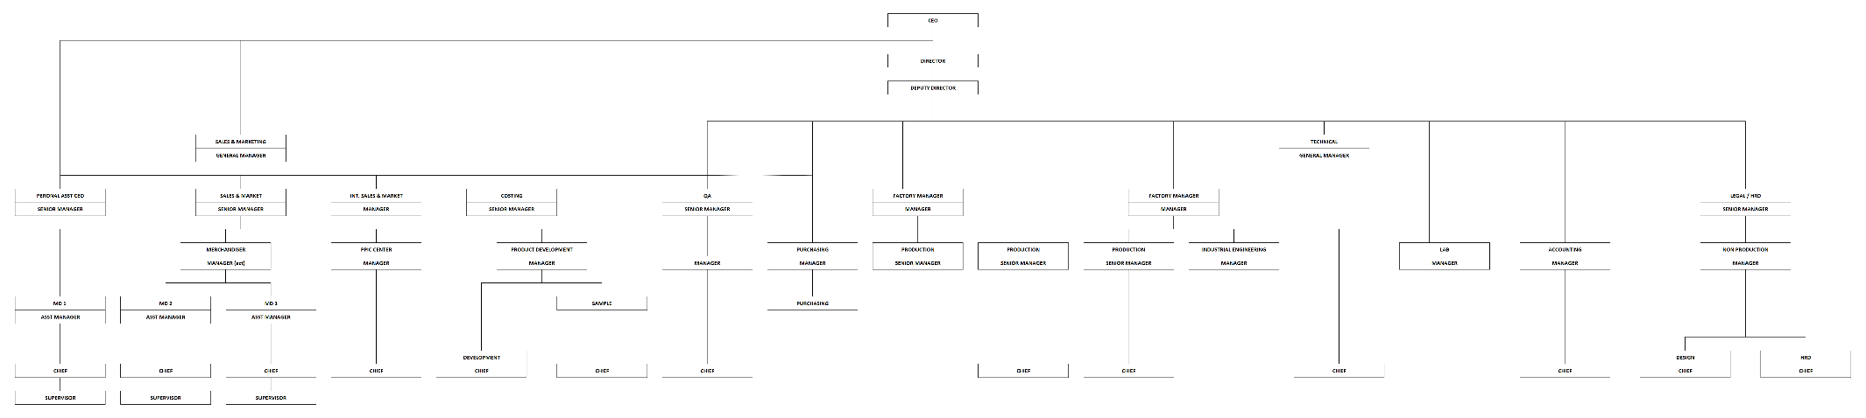

Functional Gap

Validation

SP Transaction Notification
No | If | Error Message | Note
 | UserWeb = OHEM.”U_ST_WEB_USER” | SP Notif – Web User Already Exist! | Saat Add maupun Update Employee Master Data:  - Penjagaan User Web tidak boleh ada yang sama
 | SAPUserWeb = OHEM.”U_ST_SAPB1_USER” | SP Notif – SAP B1 User Already Exist! | Saat Add maupun Update Employee Master Data:  - Penjagaan SAP Indirect User Web tidak boleh ada yang sama
 | COUNT(*) FROM @STEM_WCASGNWEBPD = 0  OR  @STEM_WCASGNWEBPD. “U_WCCode” IS NULL  OR  @STEM_WCASGNWEBPD. “U_WCCode” = ‘ ‘ | SP Notif - Document must have at least one detail line. | Saat Add maupun Update Work Center Assignment:  - Penjagaan wajib mengisikan minimal satu work center pada bagian tabel detail.
 | COUNT(*) FROM @STEM_WHSASGNWEBPD = 0  OR  @STEM_WHSASGNWEBPD. “U_WhsCode” IS NULL  OR  @STEM_WHSASGNWEBPD. “U_WhsCode” = ‘ ‘ | SP Notif - Document must have at least one detail line. | Saat Add maupun Update Warehouse Assignment:  - Penjagaan wajib mengisikan minimal satu Warehouse pada bagian tabel detail.

Addon
- SQ Material Planner, untuk menghitung kebutuhan material berdasarkan dokumen Sales Quotation (SQ), menampilkan ringkasan material, detail Bill of Material (BOM), serta memberikan rekomendasi shortage (material apa saja yang masih kurang persediaannya) untuk membantu tim MD sebelum memproses Sales Quotation menjadi Sales Order.
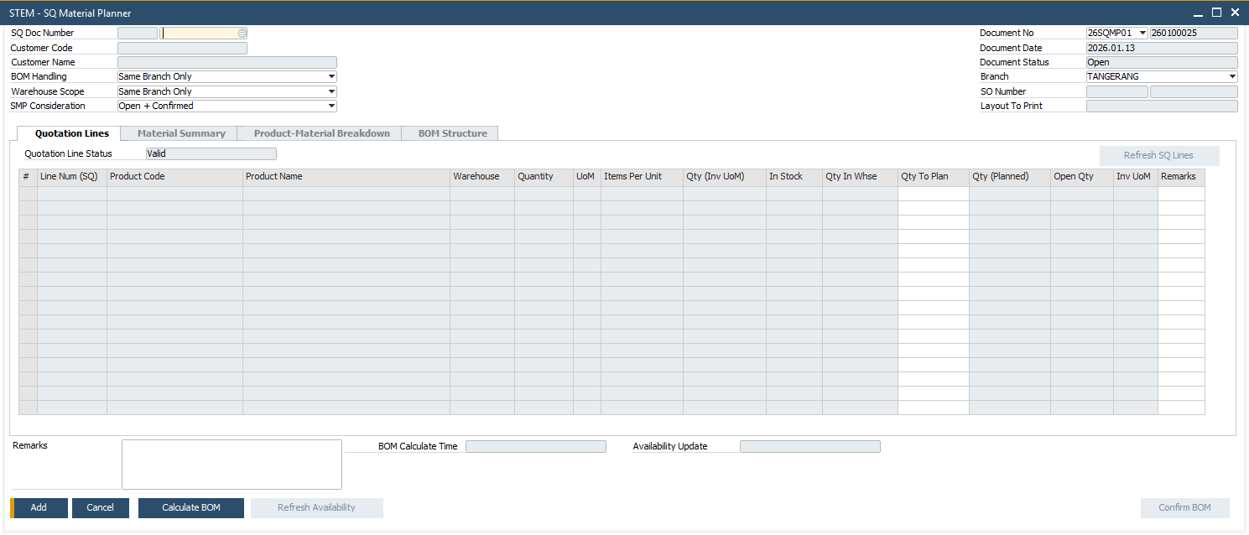

- Additional Item Group, untuk menambahkan informasi terkait pengelompokkan item sesuai kebutuhan Urecel. Terdiri dari Group 2 – Group 6.
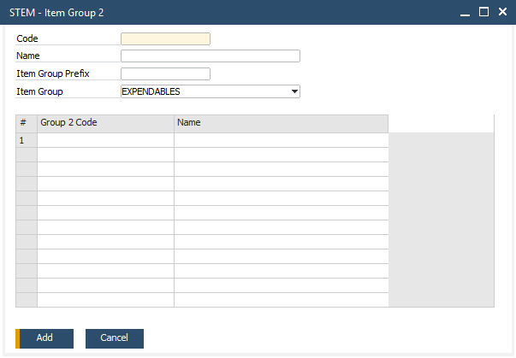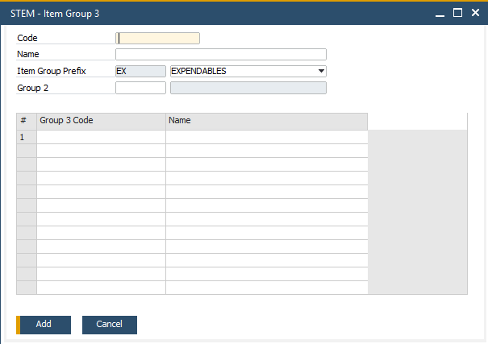
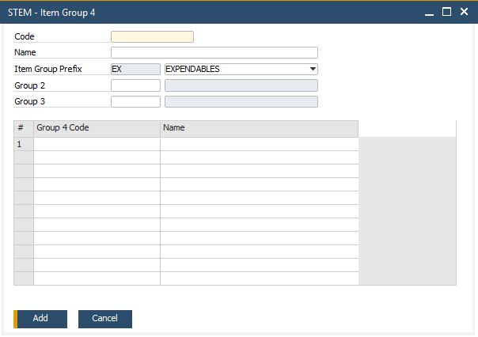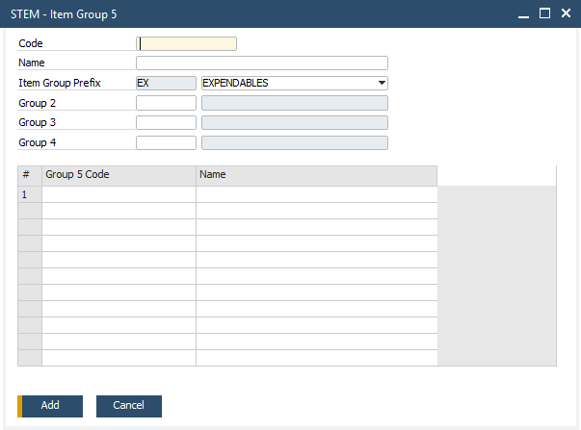
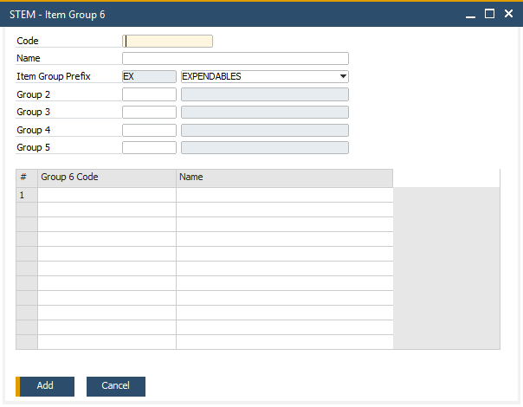

- Transfer In Branch, untuk memproses satu dokumen Inventory Transfer (IT) menjadi satu dokumen penerimaan barang (Transfer In Branch). Menu ini juga digunakan untuk melihat dokumen Transfer In Branch yang telah di-create melalui menu Transfer In Branch Generator.
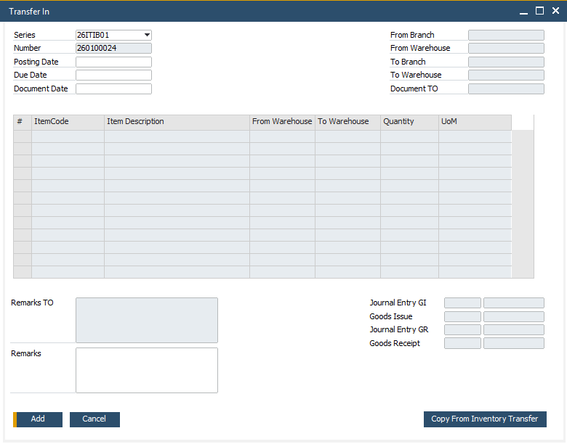

- Transfer In Branch Generator, untuk mempermudah penerimaan barang antar cabang. Dengan addon ini, user bisa memproses beberapa dokumen Inventory Transfer (IT) sekaligus hanya dalam satu kali generate.
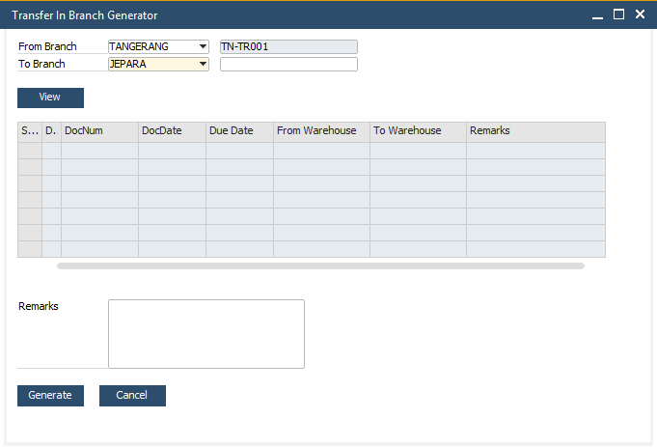

- Rework
  - Rework Type, untuk mendefinisikan tipe-tipe rework.
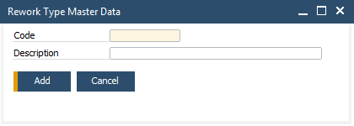

  - Rework Request, untuk mengajukan permintaan proses rework.
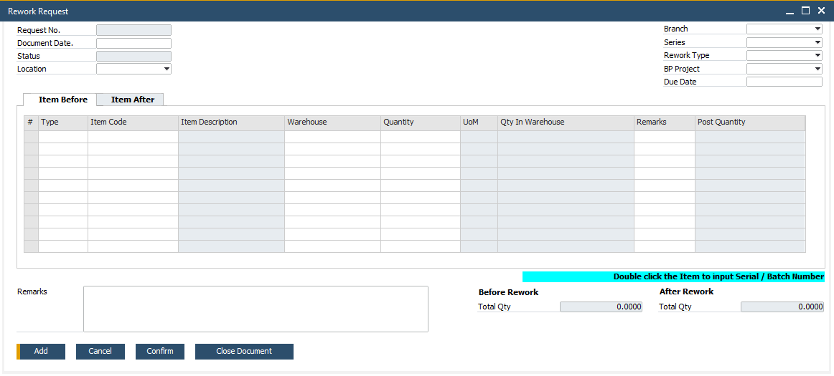
  - Post Rework, untuk melanjutkan ke proses posting rework di SAP yang menandakan bahwa Rework sudah selesai diproses.
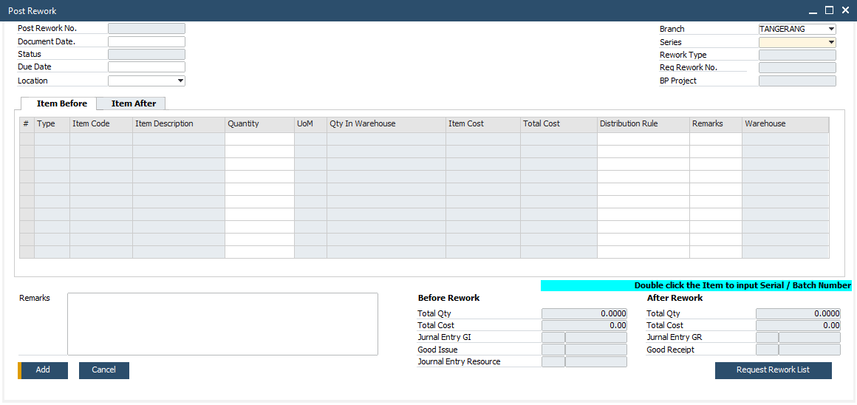

- Loading Plan, untuk membuat rencana muatan dan pengiriman berdasarkan dokumen Sales Order. Addon ini membantu tim Urecel menghitung ukuran dan berat muatan, serta menyusun urutan dan prioritas muat barang untuk kebutuhan pengiriman barang.
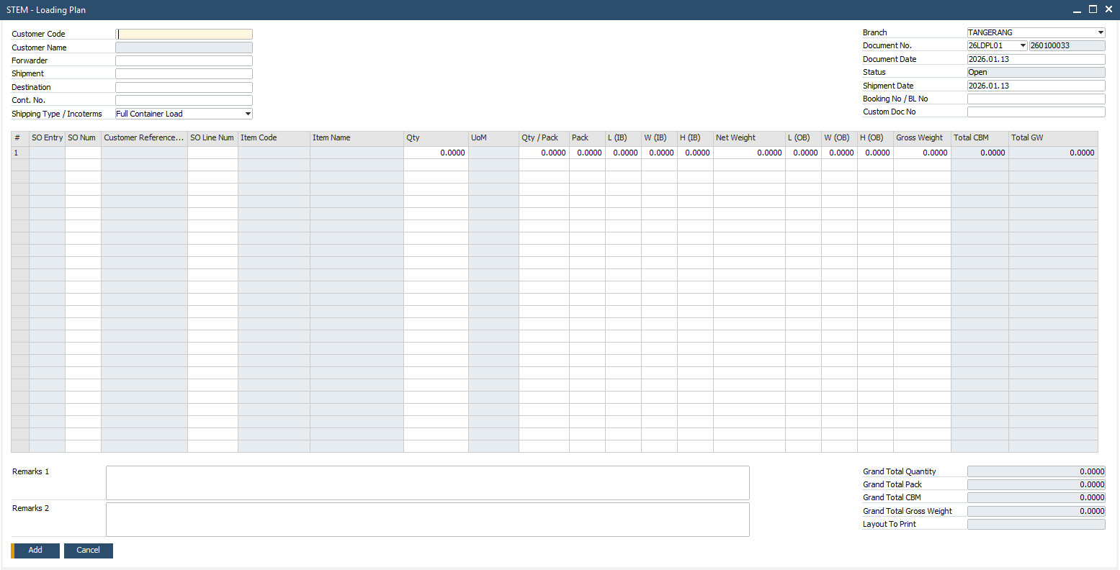

- Master Data for Production
  - Work Center Group, untuk mengelompokkan setiap work center yang digunakan dalam proses shop floor.
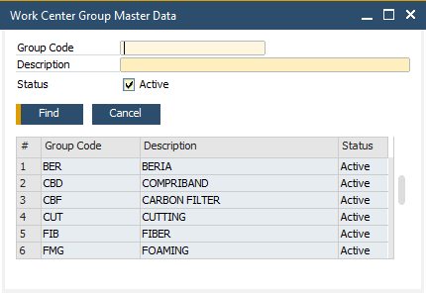

  - Work Center, untuk mendaftarkan pusat kerja/work center yang digunakan dalam proses shop floor.
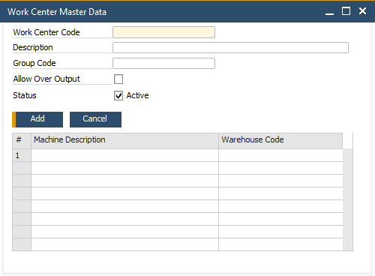

  - Route, untuk mencatat urutan dari setiap work center yang digunakan dalam proses shop floor.
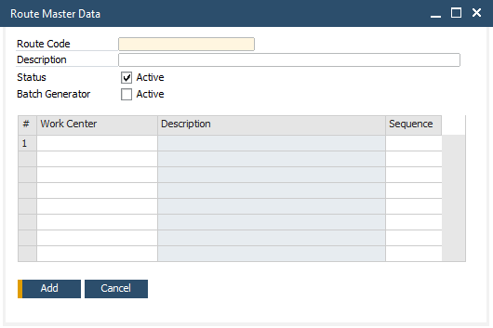

  - Specification Criteria, untuk mendefinisikan spesifikasi dari hasil produksi.
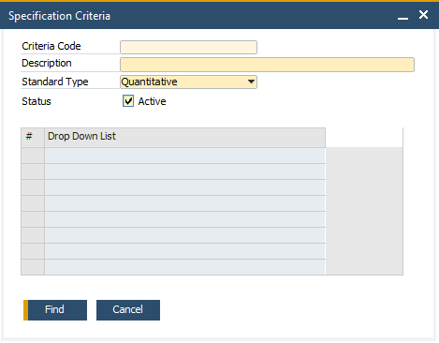

  - Specification Standard, untuk mendefinisikan standar spesifikasi yang digunakan untuk menilai hasil produksi.
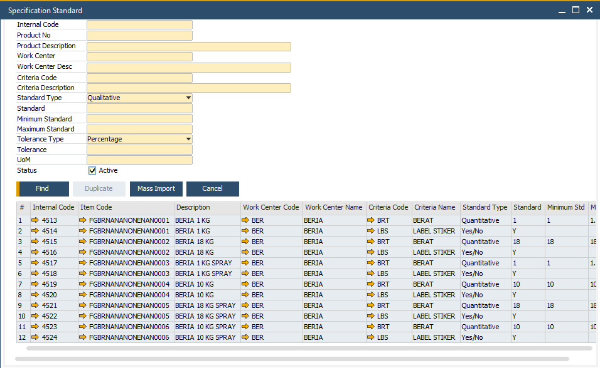

  - Reject Master Data, untuk mendaftarkan alasan penolakan hasil produksi.
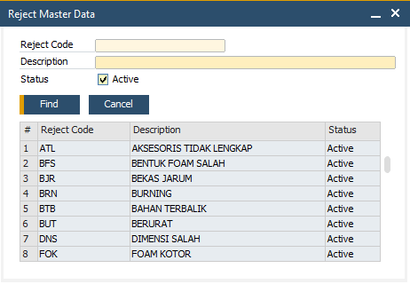

  - Shift, untuk menyimpan data shift/waktu kerja tim yang menjalankan shop floor.
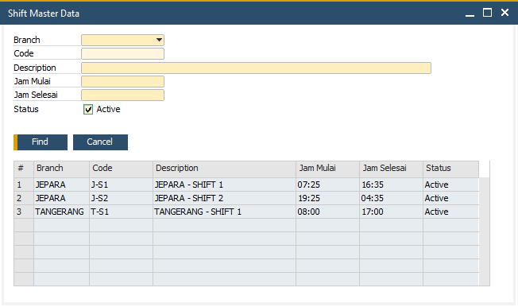

- BOM Mapping, untuk menyimpan history BOM. Hal ini karena untuk membuat suatu produk, bisa terdapat beberapa versi BOM.
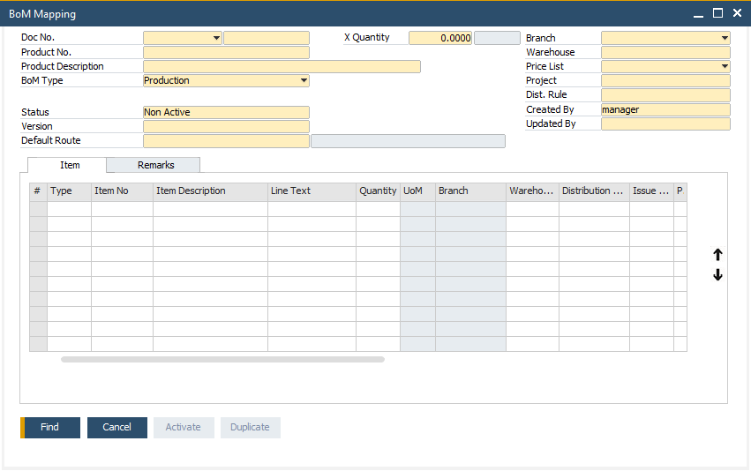

- BOM Costing, untuk mencatat perhitungan perkiraan biaya yang akan digunakan dalam produksi suatu produk.
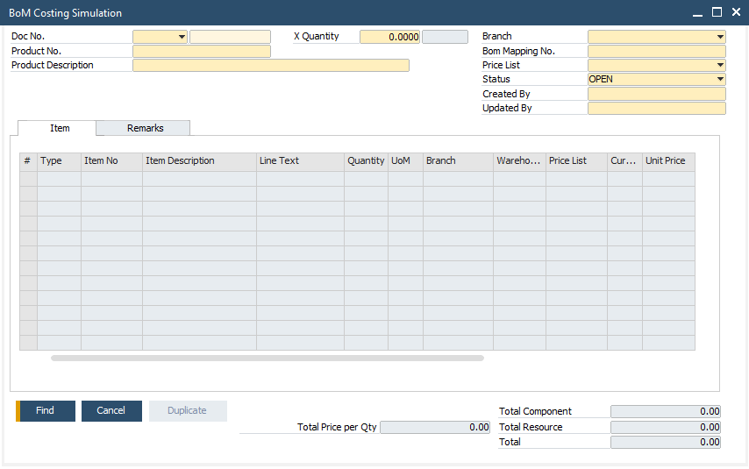

- Generate Production Order from SMP, untuk membantu proses pembuatan dokumen production order bertingkat (Leveling) berdasarkan dokumen Sales Order yang berkaitan dengan dokumen SQ Material Planner.
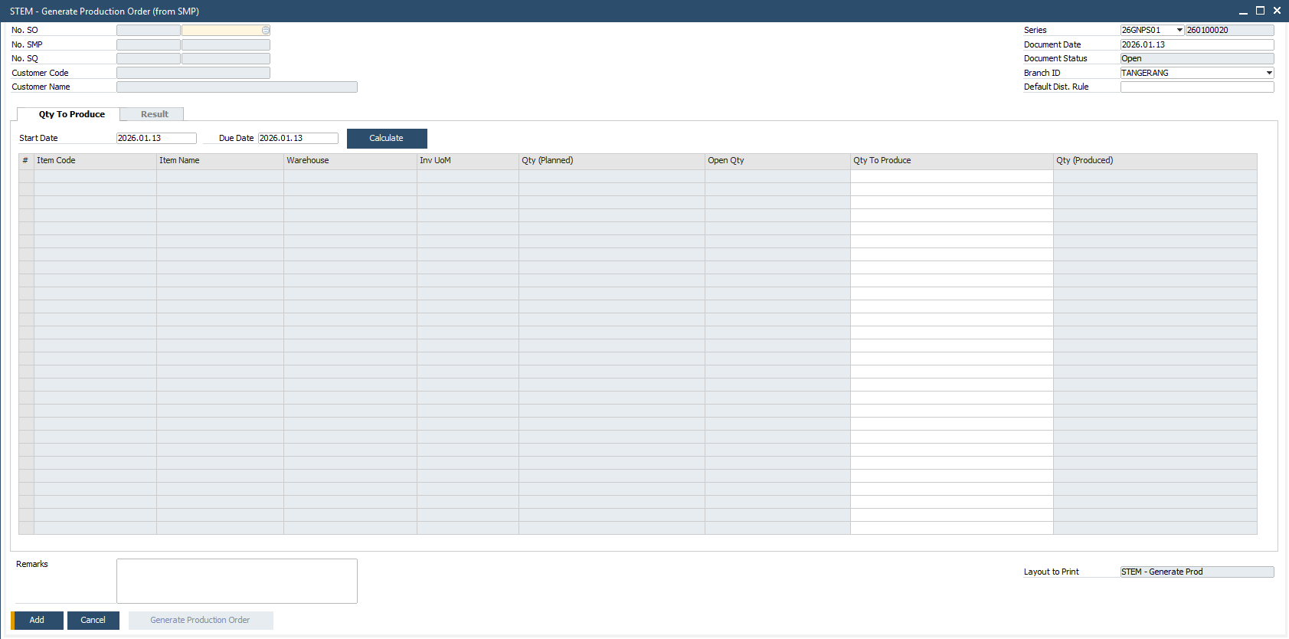

- Generate Issue For Production, untuk menghitung dan membuat dokumen Issue for Production dari beberapa nomor Production Order yang sudah berstatus Released dan memiliki item material/komponen yang sama.
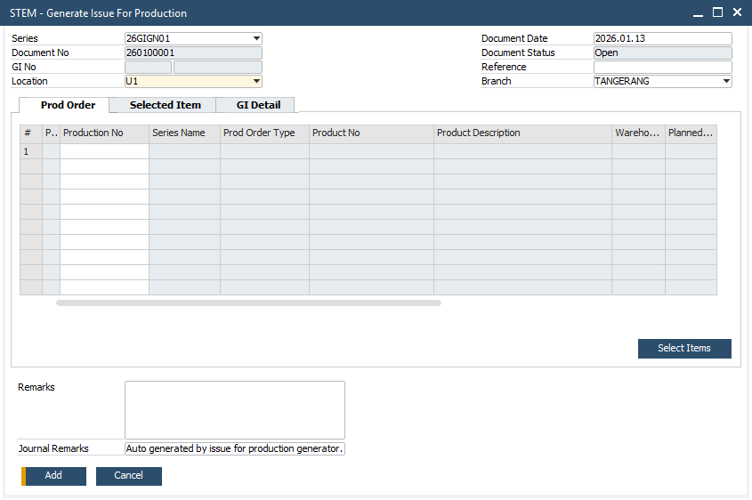

- Shop Floor Check In, untuk mencatat dimulainya sebuah proses produksi/eksekusi dari Production Order dalam sebuah Work Center.
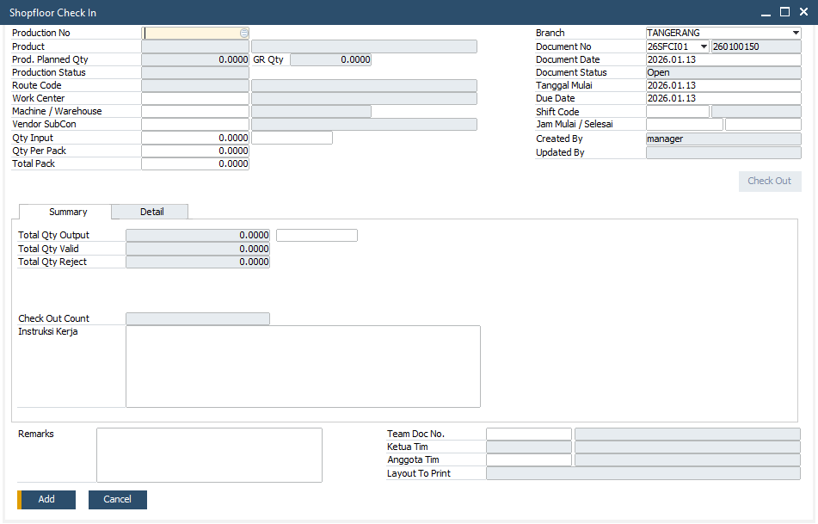

- Shop Floor Check Out, untuk mencatat selesainya sebuah proses produksi/eksekusi dari Production Order dalam sebuah Work Center.
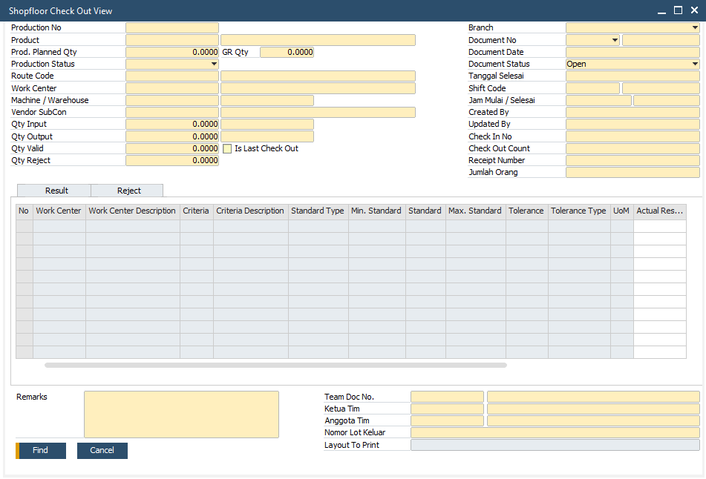

- Kwitansi, untuk membuat kwitansi berdasarkan dokumen AR Invoice yang belum pernah dibuatkan kwitansi.
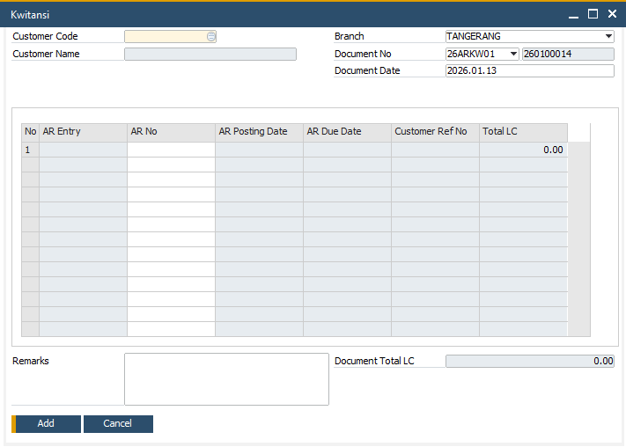

- Production Resource Revaluation, untuk menyesuaikan kembali nilai biaya produksi berdasarkan perbandingan antara Standard Cost dan Actual Cost. Addon ini secara otomatis menghitung dan menutup variance (selisih) antara biaya resource yang tercatat di Production Order dan biaya aktual di General Ledger (GL), kemudian melakukan Inventory Revaluation serta membentuk Journal Entry (JE) penyesuaian secara otomatis.
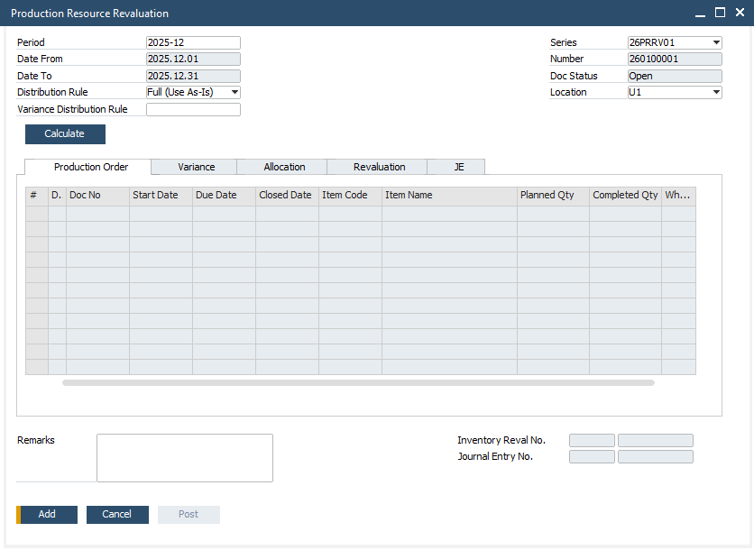

- Export VAT Out CoreTax, untuk memudahkan proses integrasi data A/R Invoice dengan Faktur Pajak Keluaran pada sistem CoreTax, sehingga user dapat menghindari penginputan ulang data yang sama pada kedua sistem.
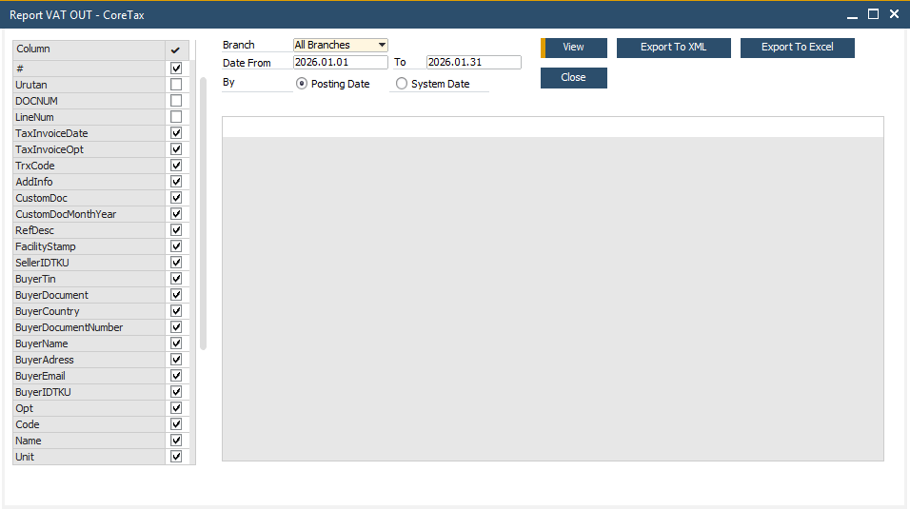
  - Add-On memunculkan UDF berikut, yang berkaitan dengan Add-On CoreTax:
    - ID TKU pada Screen Company Details, Tab Accounting.
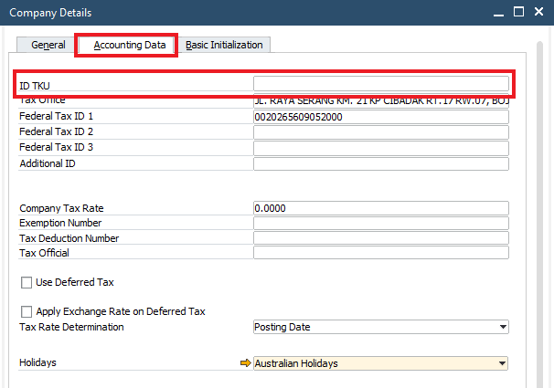

    - Country Reference CoreTax pada Screen Countries/Regions.
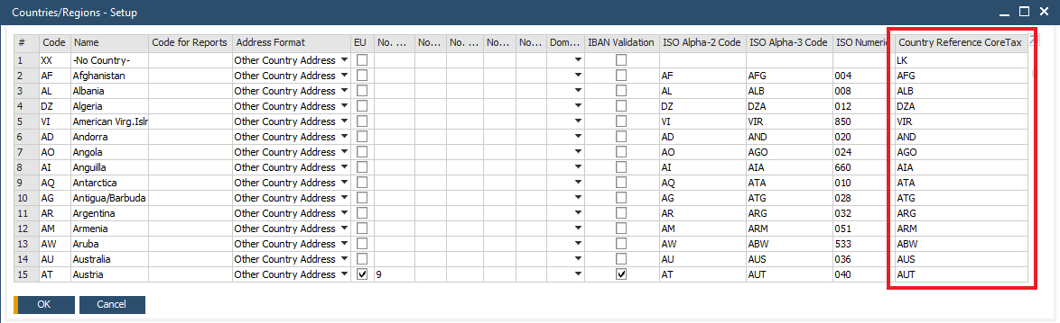

    - UOM CoreTax pada Screen Units of Measure.
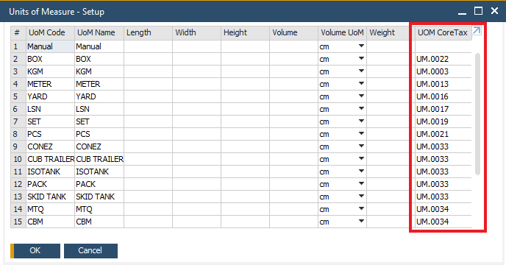

- Upload Addon
  - Excel Mapper, untuk melakukan pemetaan (mapping) data dari format excel ke format yang sesuai dengan struktur data SAP Business one sebelum proses unggah dilakukan.
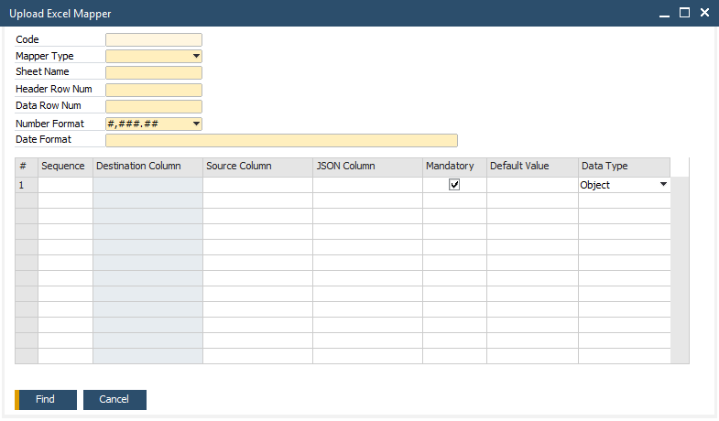

  - Upload Item Master, untuk mengupload data Item Group dan Item Master dari format excel ke dalam sistem SAP Business One.
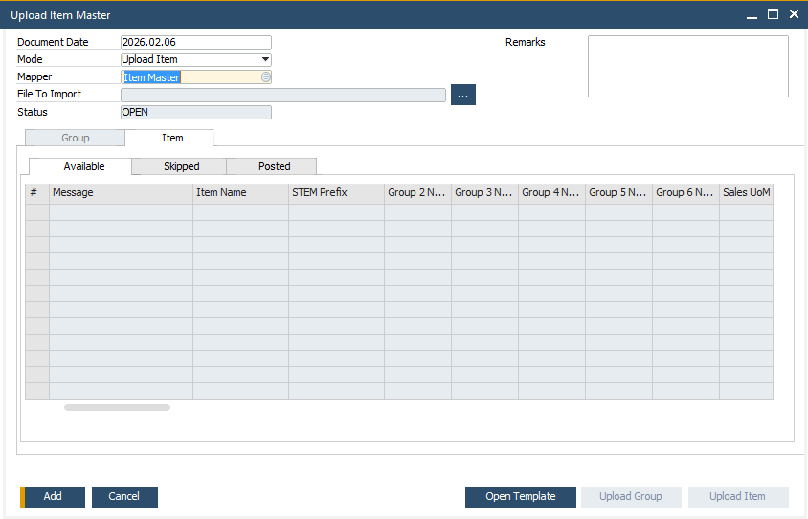

  - Upload Sales Quotation, untuk mengupload data Sales Quotation dari format excel ke dalam sistem SAP Business One.
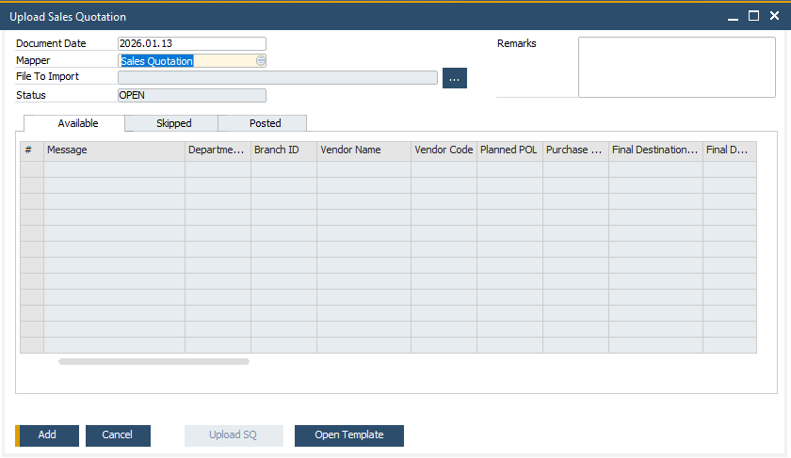

- Web Portal
  - Authorization Web Portal, untuk membuat master authorization per user, yaitu menentukan menu apa saja yang boleh diakses oleh masing-masing user iReapBiz. Dengan pengaturan ini, hak akses setiap user bisa dibatasi sesuai kebutuhan (Add / View).
  - Warehouse Assignment, untuk menentukan gudang (warehouse) mana saja yang dapat diakses dan digunakan oleh user di iReapBiz. Dengan pengaturan ini, setiap user hanya bisa melakukan transaksi di gudang yang sudah ditentukan, sehingga lebih aman dan terkontrol.
  - Work Center Assignment, untuk menentukan Work Center mana saja yang dapat diakses dan digunakan oleh user di iReapBiz. Dengan pengaturan ini, setiap user hanya bisa melakukan transaksi shopfloor yang sudah ditentukan, sehingga lebih aman dan terkontrol.
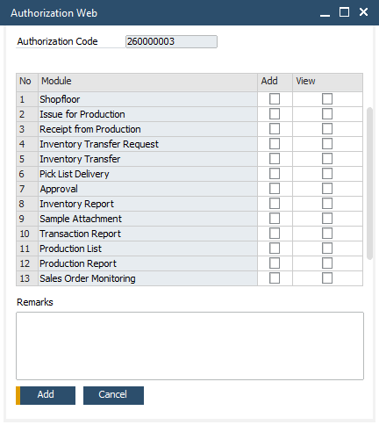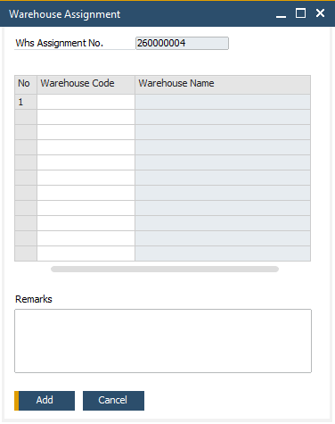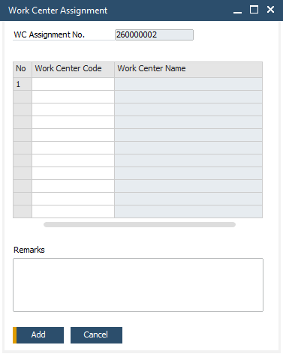

- Add-On Parameter
Berfungsi untuk menyimpan parameter untuk mengatur default value pada berbagai transaksi maupun tampilan di dalam SAP Business One dan aplikasi lain yang terintegrasi dengan SAP Business One.
Code | Description | Parameter Value | Parameter Key
1000 | Insert Param Automatic | 1 | INSERTPARAMAUTO
1001 | Rework Clearing Account GI | 911050100 | STRWKACCI
1002 | Rework Clearing Account GR | 911050100 | STRWKACCR
1003 | Path Export VAT In | (Tidak Digunakan) | VATINPATH
1004 | Path Export VAT Out | (Tidak Digunakan) | VATOUTPATH
1005 | Path Export VAT In Import | (Tidak Digunakan) | VATINIMPORTPATH
1006 | Check Regional Setting | 1 | CHECKREGIONALSETTING
1007 | Rounding Tolerance Rework | 1 | ROUNDRWCLEARING
1008 | Employee Role Shopfloor Team Leader | 1 | SFTEAMLEAD
1009 | Employee Role Shopfloor Team Member | 2 | SFTEAMMEMBER
1010 | CR Layout Name for Shopfloor Checkin | STEM - Shopfloor In,STEM - Inner Label,STEM - Outer Label | SFIN_CR_NAME
1011 | CR Layout Name for Shopfloor Checkout | STEM - Shopfloor Out | SFOUT_CR_NAME
1012 | SAP User Interface | IND1-GEN | SAPUSERINT
1013 | SAP Password Interface | 1234 | SAPPWDINT
1014 | CR Layout Name for SQ Material Planner | STEM - SQ Material Planner | SMP_CR_NAME
1015 | CR Layout Name for Generate Prodo from SMP | STEM - Generate Prod,STEM - Prod (SET Cushion Casing Core),STEM - Prod (Cushion Pcs),STEM - Prod (Casing Cover),STEM - Prod (Core),STEM - Prod (Foam Other),STEM - Prod (QR),STEM - Law Label Core,STEM - Law Label Case 1,STEM - Law Label Case 2 | GENPRODO_CR_NAME
1016 | Path Export XML VAT Out | \\192.168.155.112\hanab1h\VATOUT | XMLPATHVATOUT
1017 | INVENTORY TRANSFER BRANCH ACCOUNT GOODS ISSUE | 913020100 | ITBRACCI
1018 | INVENTORY TRANSFER BRANCH ACCOUNT GOODS RECEIPT | 913020100 | ITBRACCR
1019 | Vendor Group Vendor Subcon for Shopfloor | 112 | VGRPSUBCON
1020 | Price List ITR | 1 | PRICELISTITR
1021 | Shopfloor UOM | PCS,CBM,SET | SHOPFLOORUOM
1022 | CR Layout Name for Rework Request | STEM - Rework Request | RWKR_CR_NAME
1023 | CR Layout Name for Post Rework | STEM - Post Rework | RWKP_CR_NAME
1024 | GR Must Referenced to PO | Y | GRREFPO
1025 | PRR Revaluation Clearing Account | 911050200 | PRRREVCLRACT
1026 | PRR Variance Account | 519010100 | PRRVARACT
1027 | CR Layout Name for BOM Mapping |  | BOMMAP_CR_NAME
1028 | CR Layout Name for BOM Costing |  | BOMCOST_CR_NAME
1029 | Production Resource Revaluation Filter Period | N | PRRFILTERPERIOD
1030 | Route For Reti Batch Generator | RT-01 | ROUTERETIBATCHGEN
1031 | Item Group For Reti Batch Generator | 102 | ITMSGRPCODRETIBATCHGEN
1032 | Suffix For Reti Batch Generator(Maks 15) | R | SFXRETIBATCHGEN
1033 | GI Type for IT Branch | For Interbranch | ITBRANCHGITYPE
1034 | GR Type for IT Branch | For Interbranch | ITBRANCHGRTYPE
1035 | Rounding Tolerance for IT Branch | 1 | ITBRANCHTOLERANCE
1036 | GI Type for Rework Posting | For Rework | RWKGITYPE
1037 | GR Type for Rework Posting | For Rework | RWKGRTYPE
1038 | CR Layout Name for Loading Plan | STEM - Stuffing Checklist,STEM - Stuffing Checklist (Landscape),STEM - Packing List,STEM - Loading Plan | LP_CR_NAME
1039 | CR Layout Name for IT Branch | STEM - IT Branch | ITB_CR_NAME
1040 | URL Untuk sample ireap biz | http://192.168.155.117:8080/ireapbiz/sample/view/ | URLIREAPBIZ
1041 | CR Layout Name for Kwitansi | STEM - Kwitansi | KWI_CR_NAME
1042 | Work Center for Packing | PCK,PCV | WCPACK
1043 | DB Direct User for Query Upload | STEMUPLOAD | STEMUPLOAD_DBUSER
1044 | DB Encrypted Password for Query Upload | HEJ34jTdjbIqBEd7+zv1ew== | STEMUPLOAD_DBPASS

Formatted Search
-

User-Defined Field (UDF)
- Penambahan UDF Branch pada Screen Location.
No | Title | Description | Type | Validation
 | STEM_BRANCH | Branch | Alphanumeric (200) | None

- Penambahan beberapa UDF yang berkaitan dengan akses web iReapBiz pada Tab Web Portal, di Employee Master Data.
No | Title | Description | Type | Validation
 | ST_WEB_USER | User Web | Alphanumeric (100) | None
 | ST_WEB_PASS | Password Web | Alphanumeric (100) | None  Default Values:  42d05413557d20a 2392d725e4a1cd861
 | ST_SAPB1_USER | SAP Indirect User Web | Alphanumeric (25) | None
 | ST_SAPB1_PASS | SAP Indirect Password Web | Alphanumeric (254) | None
 | STEM_AuthorizationID | Authorization Code | Alphanumeric (10) | None
 | STEM_AuthorizationIDNum | Authorization Code Number | Alphanumeric (10) | None
 | ST_WhsAssignmentNo | Warehouse Assignment | Alphanumeric (10) | None
 | ST_WhsAssignmentDocNum | Warehouse Assignment Document Number | Alphanumeric (50) | None
 | ST_WcAssignmentNo | Work Center Assignment | Alphanumeric (10) | None
 | ST_WcAssignmentDocNum | Work Center Assignment Document Number | Alphanumeric (50) | None

Berkaitan dengan Add-On CoreTax:
- Penambahan UDF ID TKU pada Screen Company Details, Tab Accounting.
No | Title | Description | Type | Validation
 | STEM_IDTKU | ID TKU | Alphanumeric (30) | None

- Penambahan UDF Country Reference Coretax pada Screen Countries/Regions.
No | Title | Description | Type | Validation
 | STEM_COUNTRYREF | Country Reference CoreTax | Alphanumeric (10) | None

- Penambahan UDF UOM CoreTax pada Screen Units of Measure.
No | Title | Description | Type | Validation
 | STEM_CT_UOM | UOM CoreTax | Alphanumeric (20) | None

User Defined Object (UDO)
- Penambahan UDO untuk mengatur menu apa saja yang boleh diakses oleh masing-masing user di iReapBiz.
No | # | Value
1 | Unique ID | STEM_AUTHWEB
1 | Name | Authorization_WEB
1 | Type | Document
1 | Table Name | STEM_AUTHWEBH, STEM_AUTHWEBD
1 | Apply Authorization | N
1 | UI | Using SAP Default Form (Matrix Style)  Menu: Web Portal > Authorization Web Portal  Tampilan:  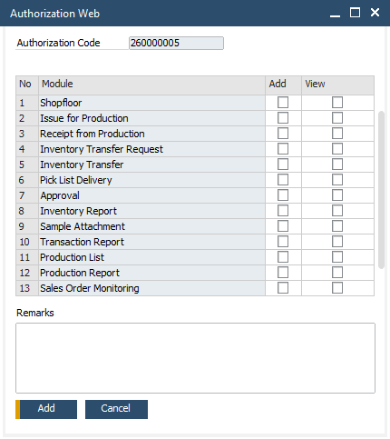

- Penambahan UDO untuk menentukan gudang (warehouse) mana saja yang dapat diakses dan digunakan oleh user di iReapBiz.
No | # | Value
1 | Unique ID | STEM_WHSASGNWEBP
1 | Name | Warehouse_Assignment
1 | Type | Document
1 | Table Name | STEM_WHSASGNWEBPH, STEM_WHSASGNWEBPD
1 | Apply Authorization | N
1 | UI | Using SAP Default Form (Matrix Style)  Menu: Web Portal > Warehouse Assignment  Tampilan:  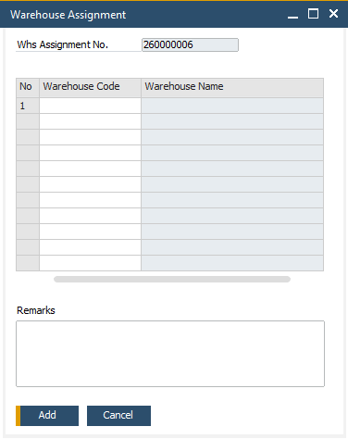

- Penambahan UDO untuk menentukan Work Center mana saja yang dapat diakses dan digunakan oleh user di iReapBiz.
No | # | Value
1 | Unique ID | STEM_WCASGNWEBP
1 | Name | Work_Center_Assignment
1 | Type | Document
1 | Table Name | STEM_WCASGNWEBPH, STEM_WCASGNWEBPD
1 | Apply Authorization | N
1 | UI | Using SAP Default Form (Matrix Style)  Menu: Web Portal > Work Center Assignment  Tampilan:  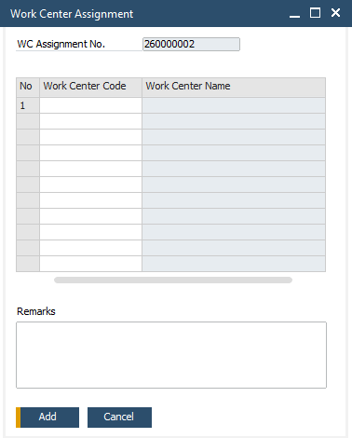

User Defined Table (UDT)
- ST_PARAM – STEM Addon Parameter
  - UDT ini untuk menyimpan parameter untuk mengatur default value pada berbagai transaksi maupun tampilan di dalam SAP Business One dan aplikasi lain yang terintegrasi dengan SAP Business One.
  - Field pada UDT ini
Field | Penjelasan
Code | Diisi dengan nomor urut.
Name | Dapat disamakan dengan isian pada field Code.
Description | Diisi dengan penjelasan parameter akan digunakan dimana.
Parameter Value | Diisi dengan nilai default dari parameter
Parameter Key | Diisi dengan kode/nama/key parameter
  - Dapat diakses dari menu Tools > User-Defined Windows > ST_PARAM – STEM Addon Parameter.
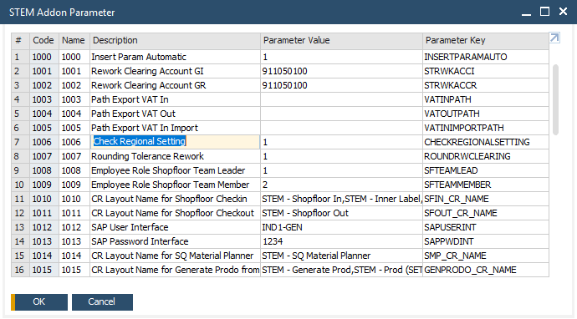

- STEM_MODULEWEB – Module Web
  - UDT ini untuk mengatur menu apa saja yang dimunculkan pada iReapBiz dan termasuk dalam kelompok menu yang mana.
  - Field pada UDT ini
Field | Penjelasan
Code | Diisi dengan kode unik (dapat disamakan dengan Module Code).
Name | Diisi dengan nama menu yang akan dimunculkan di iReapBiz.
Module Code | Diisi dengan kode modul untuk masing-masing menu.
Parent Menu | Diisi dengan nama kelompok menu.

  - Dapat diakses dari menu Tools > User-Defined Windows > STEM_MODULEWEB – Module Web.
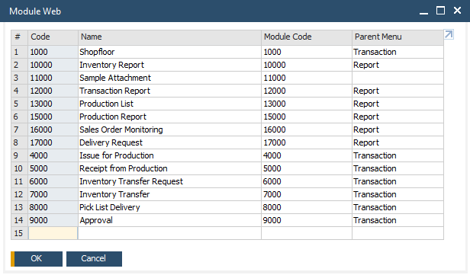

- STEM_REPORTWEB – Master Report Web
  - UDT ini untuk mengatur report apa saja yang digunakan pada masing-masing transaksi pada iReapBiz.
  - Field pada UDT ini
Field | Penjelasan
Code | Diisi dengan kode unik.
Name | Diisi dengan nama menu yang dimunculkan di iReapBiz.
Screen Code | Diisi dengan kode screen dari masing-masing menu di iReapBiz.
Report Code | Diisi dengan kode laporan.
Report Name | Diisi dengan nama laporan.
Use API Gateway | Dicentang apabila menggunakan API Gateway.

  - Dapat diakses dari menu Tools > User-Defined Windows > STEM_REPORTWEB – Master Report Web.
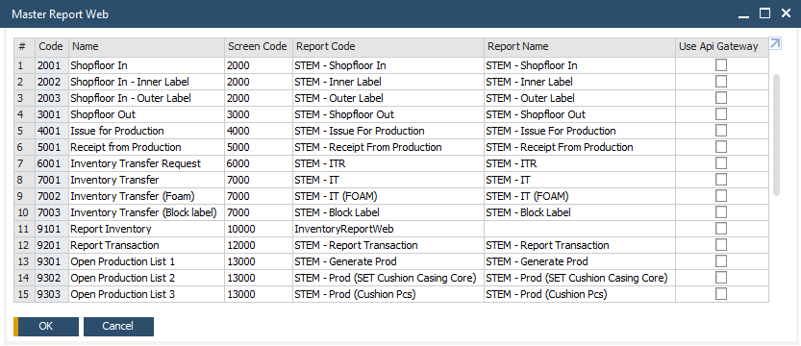

Other
Tersedia web iReapBiz yang merupakan solusi operasional terintegrasi dengan SAP. iReapBiz mendukung proses kerja tim produksi mencatat data secara cepat dan real time, sehingga tidak lagi bergantung pada pencatatan manual di kertas. Menu yang tersedia di iReapBiz, yaitu:
- Home
- Profile
- Transaction
  - Shopfloor
  - Issue for Production
  - Receipt from Production
  - Inventory Transfer Request – hanya untuk tipe Direct Transfer, sementara tipe Interbranch Transfer harus melalui SAP.
  - Inventory Transfer – hanya untuk tipe Direct Transfer, sementara tipe Interbranch Transfer harus melalui SAP.
  - Pick List Delivery – hanya untuk pick list berdasarkan dokumen Sales Order.
- Approval
- Report
  - Production List
  - Transaction Report
  - Production Report
  - Inventory Report
  - Sales Order Monitoring
  - Delivery Request
- Sample Attachment – hanya diakses oleh pelanggan yang sudah diberikan link akses untuk melihat foto dan dokumen terkait sampel.
- Production Dashboard – menampilkan rangkuman proses produksi yang telah dilakukan mulai dari Release Production Order, Inventory Transfer, Issue for Production, Shop Floor Check In, Shop Floor Check Out, dan Receipt Production Order.
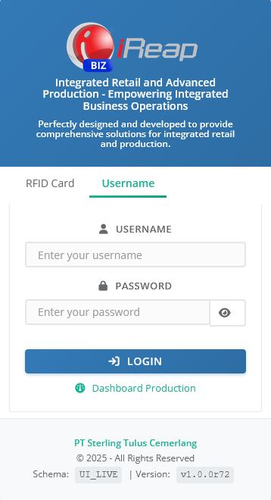
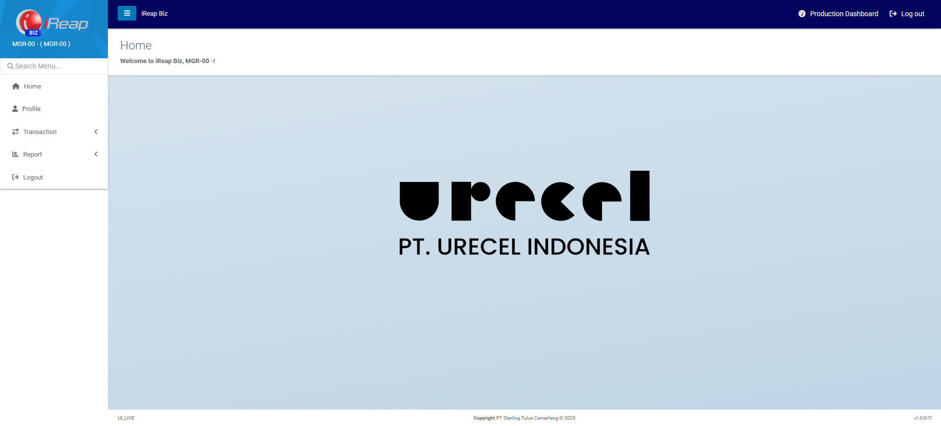

Report
-

Integration
-

Comments
- SAP Client di-install di masing-masing laptop atau PC user.
- Pada laptop atau PC user perlu diatur terkait:
  - Region – pastikan terisi United States
  - Language – pastikan terpilih English (United States)
- Terdapat penjagaan saat Connected Addon, apabila Region pada laptop/PC user belum terisi United States, maka akan muncul warning.
- Dibuatkan User Default yang dipasang pada masing-masing User:
  - TNG – untuk branch Tangerang
  - JPR – untuk branch Jepara
Branch pada seluruh transaksi dan addon akan membaca User Default yang dipasang pada User yang sedang login ke SAP.
- Dengan diisikan User Default pada User, maka saat login awal, jendela Select Default Branch tidak lagi dimunculkan secara otomatis. Walaupun sudah ditentukan default branch, namun user (khusus user dengan multiple branch) masih bisa menggantinya secara manual melalui toolbar Default Branch Selection apabila dibutuhkan.

Version Control
Date | Author | Version | Change Reference
04-Aug-2025 | Jennie Lou | 1.00 | First Draft
18-Aug-2025 | Jennie Lou | 1.01 | Update Company Detail, Organization Structure, Profit Center, House Banks, Banks, Withholding Tax, Default Warehouse, Default Payment Term.
17-Sep-2025 | Happy Niti Noor Muchsin | 1.02 | Update Business Owner
26-Sep-2025 | Happy Niti Noor Muchsin | 1.03 | Review Blueprint
01-Oct-2025 | Jennie Lou | 1.04 | Document Number Digit,  Data Cost Center, Data UoM, Data House Bank, & Data Bank
21-Jan-2026 | Chatrine Sylvia | 1.05 | - Update Company Details  - Update General Parameter  - Update Functional Gap, and  - Update Comments

